Transcriptomic Profiling of Ferroptosis-Related Genes in Myocardial Infarction and Heart Failure

Abstract
Cardiovascular diseases (CVDs), in particular myocardial infarction (MI) and heart failure (HF), constitute a leading cause of morbidity and mortality worldwide, collectively imposing an immense clinical and socioeconomic burden. Over the past decade, accumulating evidence has drawn attention to ferroptosis—an iron-dependent, non-apoptotic form of regulated cell death driven by uncontrolled lipid peroxidation and the collapse of the cellular antioxidant defense system—as a mechanistically significant contributor to ischemic and non-ischemic cardiac injury. Despite this growing recognition, the specific ferroptosis-associated transcriptomic signatures underlying myocardial infarction and heart failure remain incompletely characterized, particularly with respect to their differential involvement across acute versus chronic disease states.
The present study aimed to address this gap by conducting an integrated transcriptomic analysis of publicly available gene expression datasets to identify ferroptosis-related genes and molecular pathways operative in myocardial infarction and heart failure. Transcriptomic datasets pertaining to both conditions were retrieved from the National Center for Biotechnology Information (NCBI) Gene Expression Omnibus (GEO) database, subjected to systematic preprocessing and normalization, and independently analyzed for differential gene expression. The resulting differentially expressed genes (DEGs) were subsequently intersected with a curated compendium of ferroptosis-associated genes sourced from the FerrDb database, enabling precise identification of ferroptosis-relevant molecular signatures within each cardiovascular context.
To enhance the biological reproducibility of the heart failure analysis, a consensus-based multi-dataset integration strategy was employed, retaining only those genes consistently dysregulated across independent HF datasets. Functional characterization of the identified ferroptosis-associated DEGs was accomplished through Gene Ontology (GO) enrichment analysis and Kyoto Encyclopedia of Genes and Genomes (KEGG) pathway analysis using the Enrichr platform. Visualization of expression profiles was carried out via hierarchically clustered heatmaps and volcano plots. Protein–protein interaction (PPI) network analysis was performed using the STRING database to delineate molecular interaction architectures and to identify candidate hub genes with regulatory prominence.
The analysis revealed a set of 38 ferroptosis-related genes associated with myocardial infarction, alongside six ferroptosis-associated genes—ALOX5, ESR1, SNCA, ATP1A3, FRZB, and XIST—identified through consensus integration of heart failure datasets. GO enrichment analysis demonstrated significant involvement of the identified genes in apoptotic regulation, reactive oxygen species (ROS) metabolic processes, oxidative stress response, lipid metabolism, inflammatory signaling, and endothelial dysfunction. KEGG pathway analysis highlighted enrichment of the NF-κB signaling pathway, arachidonic acid metabolism, calcium signaling, extracellular matrix (ECM)–receptor interaction, and several immune-related cascades. STRING network analysis identified IGF2BP3, THBS1, METTL3, HNRNPD, and PDK4 as major hub genes in the MI interaction network, while ALOX5, ESR1, and SNCA emerged as biologically significant nodes within the HF network.
These findings collectively establish that ferroptosis engages cardiovascular pathology through distinct molecular mechanisms in acute myocardial injury versus chronic heart failure remodeling. The identified ferroptosis-associated genes and enriched pathways represent a compelling repertoire of candidate biomarkers and therapeutic targets for future investigations into the molecular basis and clinical management of cardiovascular disease.

1. Introduction
Cardiovascular diseases remain the foremost cause of premature death and disability across the globe, claiming more lives annually than any other class of disorders. Within this broad clinical category, myocardial infarction and heart failure represent perhaps the most consequential and mechanistically intertwined entities. Myocardial infarction arises from the abrupt occlusion of one or more coronary arteries, typically precipitated by the rupture of an atherosclerotic plaque and the ensuing formation of an obstructive thrombus. The resultant interruption of myocardial perfusion initiates a cascade of ischemic injury that, if not reversed promptly, progresses to irreversible necrosis of cardiomyocytes. While timely reperfusion through primary percutaneous coronary intervention has substantially reduced acute mortality, the myocardial scar that forms in the aftermath of infarction sets the stage for pathological ventricular remodeling, progressive deterioration of cardiac contractile function, and, ultimately, the development of heart failure.
Heart failure is a complex chronic syndrome characterized by the inability of the heart to generate sufficient output to meet the metabolic demands of peripheral tissues, manifesting clinically as dyspnea, fatigue, fluid retention, and markedly diminished exercise tolerance. Its pathophysiology encompasses maladaptive neurohormonal activation, adverse cardiomyocyte hypertrophy and fibrosis, impaired calcium handling, mitochondrial energetic failure, and persistent low-grade inflammation. These overlapping mechanisms underscore the mechanistic continuum that connects MI to HF, while simultaneously highlighting the plurality of molecular processes that must be understood and targeted to halt disease progression.
Among the various molecular mechanisms implicated in cardiac injury, regulated cell death pathways have attracted increasing investigative interest. Cardiomyocytes, being terminally differentiated and effectively non-regenerative in the adult myocardium, are exquisitely sensitive to cell death stimuli, and even modest losses of viable cardiac muscle are clinically consequential. Although apoptosis and necrosis have been extensively studied in this context, it has become increasingly clear that neither mechanism alone accounts for the full spectrum of cardiomyocyte loss observed in ischemic and non-ischemic heart disease. The emergence of ferroptosis as a distinct, mechanistically unique form of regulated cell death has therefore opened a new investigative frontier in cardiovascular biology.
Ferroptosis, first formally characterized in 2012 by Dixon and colleagues, is fundamentally driven by the iron-catalyzed peroxidation of polyunsaturated fatty acid (PUFA)-containing phospholipids within cellular membranes. Unlike the caspase-dependent molecular machinery of apoptosis, or the plasma membrane rupture characteristic of classical necrosis, ferroptosis is defined by the progressive accumulation of toxic lipid hydroperoxides, the depletion of intracellular glutathione, and the inactivation of glutathione peroxidase 4 (GPX4)—the principal enzymatic guardian against lipid peroxide accumulation. Iron plays an indispensable catalytic role through its participation in Fenton-type reactions, which generate highly reactive hydroxyl radicals that initiate and perpetuate lipid radical chain reactions. Cells undergoing ferroptosis exhibit characteristic ultrastructural changes, most notably mitochondrial shrinkage, cristae disruption, and condensation of the mitochondrial membrane, distinguishing them from cells dying by other mechanisms.
The relevance of ferroptosis to cardiac pathophysiology is supported by a growing body of experimental evidence. Studies employing ferrostatin-1 and other ferroptosis inhibitors have demonstrated significant cardioprotection in murine models of ischemia–reperfusion injury, indicating that ferroptotic cell death is an active contributor to reperfusion-mediated cardiomyocyte loss. Conditional knockout of GPX4 in cardiomyocytes has been shown to precipitate a dilated cardiomyopathy phenotype, reinforcing the notion that disruption of the antioxidant lipid-repair axis is sufficient to induce heart failure. Moreover, accumulation of iron—a condition frequently encountered in failing hearts due to dysregulated iron homeostasis—potentiates ferroptotic sensitivity and has been mechanistically linked to adverse cardiac remodeling. Lipoxygenases, particularly ALOX5 and ALOX15, generate leukotriene-class lipid mediators and lipid hydroperoxides respectively, representing enzymatic conduits through which inflammatory and oxidative signals intersect with ferroptotic execution in cardiac tissue.
Despite these experimental insights, the transcriptomic landscape of ferroptosis in human cardiovascular disease has not been comprehensively mapped. Understanding which ferroptosis-associated genes are consistently dysregulated in patient-derived cardiac transcriptomes, and how these genes are functionally interconnected through signaling pathways and protein interaction networks, is essential for translating mechanistic insights into clinically applicable biomarkers and therapeutic strategies. The bioinformatics revolution, combined with the availability of extensive publicly archived transcriptomic datasets in repositories such as the GEO, has created an unprecedented opportunity to address these questions through integrated computational analysis.
Recent advances in transcriptomic profiling have enabled genome-wide characterization of gene expression changes in human disease tissues without the ethical and practical limitations inherent to obtaining primary cardiac biopsy material at scale. Microarray and RNA-sequencing technologies generate high-dimensional expression matrices that, when subjected to rigorous statistical analysis, reveal the molecular signatures of disease with considerable resolution. Integrating multiple independent datasets obtained from diverse patient cohorts not only amplifies statistical power but also filters out dataset-specific noise, yielding more reproducible and biologically credible gene lists. Downstream pathway enrichment analyses contextualize raw gene lists within established frameworks of cellular biology, while PPI network analysis illuminates the topological organization of molecular interactions and identifies key regulatory nodes.
The FerrDb database provides a meticulously curated, experimentally validated compendium of ferroptosis-related genes classified as drivers, suppressors, or markers of ferroptosis, offering an authoritative reference for identifying ferroptosis-relevant transcriptomic alterations. Its intersection with disease-associated DEGs provides a powerful and specific approach for isolating the ferroptotic component of broader transcriptional dysregulation in cardiovascular disease.
The present study was designed to harness these methodological capabilities in a systematic investigation of ferroptosis-associated transcriptomic signatures in myocardial infarction and heart failure. By integrating differential gene expression analysis, multi-dataset consensus filtering, FerrDb intersection, GO and KEGG enrichment analysis, heatmap and volcano plot visualization, STRING-based PPI network construction, and hub gene identification, this work aims to provide a comprehensive molecular portrait of ferroptosis in human cardiac disease—one that may inform the development of novel diagnostic biomarkers and targeted therapeutic interventions.
2. Literature Review

2.1 Cardiovascular Disease: Epidemiology and Pathophysiology
Cardiovascular diseases represent a heterogeneous group of disorders affecting the heart and vasculature that collectively constitute the leading cause of mortality in virtually every region of the world. According to estimates from the World Health Organization and the Global Burden of Disease Study, CVDs account for approximately 17–18 million deaths annually, with ischemic heart disease and heart failure contributing disproportionately to this toll. The pathophysiology of myocardial infarction centers on the disruption of coronary blood supply, most frequently as a consequence of atherosclerotic plaque instability, thrombosis, and vessel occlusion. Ischemia rapidly compromises cardiomyocyte energetics by depleting ATP stores, disrupting ion homeostasis, and generating a burst of reactive oxygen species from mitochondria operating under oxygen limitation. Although early reperfusion is the primary therapeutic goal in acute MI, the restoration of blood flow paradoxically aggravates injury through the massive production of ROS, calcium overload, and inflammatory cell infiltration—a phenomenon collectively described as ischemia–reperfusion (I/R) injury.
The transition from acute MI to chronic heart failure is governed by a constellation of maladaptive responses, including neurohormonal activation of the renin–angiotensin–aldosterone system and sympathetic nervous system, pathological myocyte hypertrophy, extracellular matrix remodeling with progressive fibrotic replacement of functional myocardium, and impaired excitation–contraction coupling due to dysregulated calcium handling. These processes collectively reduce ventricular compliance and contractile reserve, ultimately manifesting as the clinical syndrome of heart failure. The distinction between acute ischemic injury and chronic remodeling is not merely descriptive but reflects fundamentally different molecular environments: the former is characterized by intense but transient oxidative bursts and inflammatory activation, while the latter involves sustained, low-grade but relentlessly progressive metabolic, inflammatory, and structural changes.

2.2 Ferroptosis: Mechanism and Molecular Biology
Ferroptosis occupies a unique niche in the taxonomy of cell death, distinguished by its absolute dependence on iron and on the oxidative destruction of membrane phospholipids. The seminal description of ferroptosis as a genetically and biochemically distinct form of regulated necrosis was provided by Dixon et al. in 2012, who demonstrated that the small molecule erastin induced cell death through a mechanism entirely distinct from apoptosis, autophagy, or classical necrosis. Subsequent work has elucidated the molecular architecture of the ferroptotic execution machinery with increasing precision.
The central biochemical event in ferroptosis is the peroxidation of phospholipids containing polyunsaturated fatty acid chains—most notably arachidonic acid and adrenic acid—within cellular membranes. This process is catalyzed by non-enzymatic radical chain reactions as well as by enzymatic oxidases, particularly lipoxygenases (ALOX family) and cytochrome P450 oxidoreductase (POR). The resulting phospholipid hydroperoxides (PLOOHs) are normally reduced to their corresponding alcohols by GPX4, a selenocysteine-containing enzyme that uses glutathione as the reducing cofactor. GPX4 thus constitutes the principal suppressor of ferroptosis, and its genetic deletion or pharmacological inhibition is sufficient to induce ferroptotic cell death in virtually all cell types examined.
Glutathione synthesis depends critically on the import of cystine via the system Xc– transporter, encoded by SLC7A11 and SLC3A2. Erastin, the compound used in the original ferroptosis characterization, exerts its lethal effect by blocking system Xc–, thereby depleting intracellular cystine and, consequently, glutathione. Alternative mechanisms of ferroptosis induction converge on GPX4 inactivation through the depletion of its cofactor or through direct chemical inhibition. More recently, a GPX4-independent ferroptosis pathway has been described, mediated by the depletion of coenzyme Q10 (ubiquinol) at the plasma membrane through inhibition of the ferroptosis suppressor protein 1 (FSP1)–CoQ10 axis.
Iron metabolism is intimately entangled with ferroptotic sensitivity. Intracellular labile iron—predominantly in the ferrous (Fe²⁺) form—catalyzes the oxidation of PUFAs through Fenton chemistry, generating reactive oxygen species that propagate lipid radical chain reactions. Accordingly, processes that increase the labile iron pool, including lysosomal ferritin degradation (ferritinophagy), transferrin receptor–mediated iron uptake, and impaired iron export through ferroportin, all potentiate ferroptotic susceptibility. Conversely, iron chelation with agents such as deferoxamine effectively suppresses ferroptosis. The interplay between iron storage (mediated by ferritin heavy and light chains), iron trafficking (involving transferrin and transferrin receptor), and iron export constitutes a critical regulatory axis governing cellular ferroptotic tone.

2.3 Ferroptosis in Cardiovascular Disease
The experimental demonstration of ferroptosis in cardiac biology began with observations that myocardial I/R injury could be attenuated by ferrostatin-1, a lipophilic radical-trapping antioxidant that specifically inhibits lipid peroxidation without affecting other cell death pathways. Subsequent work confirmed that ferroptotic markers—including elevated 4-hydroxynonenal (4-HNE) adducts, decreased GPX4 protein, and depleted glutathione—are readily detectable in ischemic cardiac tissue, both in experimental animal models and in human biopsy samples from patients with ischemic cardiomyopathy.
The involvement of ferroptosis in heart failure, beyond the acute ischemic context, has been supported by multiple lines of evidence. Cardiomyocyte-specific GPX4 knockout mice develop a spontaneous dilated cardiomyopathy phenotype that is attenuated by ferrostatin-1 treatment, establishing a causal rather than merely correlative relationship between GPX4 insufficiency, unrestrained lipid peroxidation, and heart failure. Iron overload cardiomyopathy, a clinically recognized entity in conditions such as hereditary hemochromatosis and transfusion-dependent anemias, likely involves ferroptotic components given the central role of labile iron in propagating lipid peroxidation. Emerging evidence also implicates ferroptosis in diabetic cardiomyopathy and doxorubicin-induced cardiotoxicity, extending its pathological relevance across a wider spectrum of cardiac disorders.
Several specific ferroptosis-related genes have emerged as particularly relevant in the cardiovascular context. ACSL4, which catalyzes the esterification of arachidonic acid into phospholipids and thereby enriches membranes with the PUFA substrate for ferroptotic peroxidation, is upregulated in ischemic cardiac tissue and correlates with ferroptotic injury severity. ALOX5 and ALOX15 generate lipid hydroperoxide species and leukotriene mediators that contribute to both inflammatory signaling and ferroptotic execution. SLC7A11 expression is regulated by multiple cardioprotective transcription factors, including NRF2, and its downregulation under oxidative or ischemic stress sensitizes cardiomyocytes to ferroptosis. FTH1, encoding ferritin heavy chain, functions as a ferroptosis suppressor by sequestering labile iron, and its destabilization through autophagy (ferritinophagy) amplifies ferroptotic susceptibility in cardiac ischemia.

2.4 Transcriptomic Approaches in Cardiovascular Research
The application of high-throughput transcriptomics to cardiovascular disease has generated rich datasets cataloging the gene expression landscapes of infarcted and failing myocardium. Microarray platforms, which measure the hybridization of labeled cDNA to thousands of oligonucleotide probes simultaneously, were the dominant technology in earlier transcriptomic studies and continue to yield valuable data. RNA sequencing has subsequently emerged as the gold standard for transcriptome-wide expression profiling, offering superior dynamic range, the ability to detect novel transcripts and splice variants, and quantitative accuracy without saturation effects.
The GEO repository, maintained by NCBI, currently archives tens of thousands of publicly available transcriptomic datasets spanning virtually every biological system and disease condition, including an extensive collection of cardiovascular studies. Mining this resource through integrative meta-analysis approaches amplifies the statistical power of individual studies, reduces platform-specific noise, and enables the identification of transcriptomic signatures that are robust across heterogeneous patient populations. Consensus filtering strategies, which retain only genes consistently dysregulated across multiple independent datasets, have proven particularly effective in identifying high-confidence molecular markers.
Bioinformatics tools for pathway enrichment analysis—including Gene Ontology annotation, KEGG pathway mapping, Reactome database analysis, and gene set enrichment analysis (GSEA)—provide the biological context necessary to interpret large gene lists. These approaches transform lists of dysregulated genes into biologically interpretable insights about the cellular processes and signaling pathways that are perturbed in disease. PPI network analysis, in turn, models the physical and functional relationships among gene products, enabling the identification of network hubs that may play disproportionately important regulatory roles. Integration of these complementary analytical strategies, as employed in the present study, offers a holistic view of disease-associated transcriptomic dysregulation.
3. Objectives
- To identify ferroptosis-related genes by intersecting differentially expressed genes (DEGs) with the FerrDb database.
- To determine common ferroptosis-related hub genes across cardiac diseases using network and enrichment analysis.

4. Methodology

4.1 Retrieval of Transcriptomic Datasets
Publicly available transcriptomic microarray datasets related to myocardial infarction and heart failure were systematically retrieved from the NCBI Gene Expression Omnibus (GEO) database, one of the most comprehensive publicly accessible repositories for high-throughput gene expression data. GEO archives experimentally validated transcriptomic datasets derived from a wide variety of microarray and RNA-sequencing platforms, making it an indispensable resource for computational investigation of disease-associated molecular mechanisms.
Datasets were selected based on a defined set of inclusion criteria to ensure analytical rigor and biological relevance. Eligible datasets were required to include both disease samples and matched or comparable healthy control samples from human subjects, to involve cardiovascular tissue or clinically informative peripheral samples directly relevant to MI or HF pathophysiology, and to provide a sufficient number of independent biological replicates to permit meaningful statistical comparison. Additionally, datasets were required to be accompanied by complete platform annotation files to facilitate accurate probe-to-gene mapping, and to be compatible with downstream bioinformatics analysis pipelines.
Multiple independent datasets were incorporated for each disease condition. This multi-dataset approach serves several important analytical purposes: it substantially increases the overall sample size and statistical power of the analysis; it enables the identification of transcriptomic signatures that are reproduced across different patient cohorts, experimental laboratories, and microarray platforms; and it allows consensus-based integration strategies that effectively filter out dataset-specific noise and platform-related batch effects. For myocardial infarction, datasets containing expression profiles from ischemic or acutely infarcted cardiac tissue alongside healthy control myocardium were selected. For heart failure, datasets comprising failing myocardium encompassing dilated and ischemic cardiomyopathy cases and non-failing donor hearts were included. Associated metadata, including sample classification, anatomical tissue source, and detailed experimental descriptions, were carefully examined prior to analysis to ensure appropriate sample assignment and to avoid inadvertent mixing of disease subtypes.
Platform annotation files for each selected dataset were additionally retrieved from GEO to support downstream probe-to-gene symbol conversion. The use of publicly archived transcriptomic data provided a cost-effective, reproducible, and ethically unconstrained basis for investigating ferroptosis-associated molecular mechanisms in human cardiovascular disease at a scale that would be logistically impractical through primary sample collection.

4.2 Data Preprocessing and Normalization
Following dataset retrieval, the raw expression matrices were imported into the Python programming environment for systematic preprocessing, quality control, annotation correction, and normalization. Microarray datasets sourced from GEO frequently exhibit several categories of technical heterogeneity that must be addressed prior to differential expression analysis, including platform-specific probe design differences, missing or incomplete probe annotations, redundant multi-probe mappings to single genes, and inter-sample variability introduced by inconsistencies in hybridization conditions, scanner settings, and array batch effects.
Each dataset was initially subjected to a comprehensive quality inspection to identify missing values, duplicate probe entries, improperly annotated records, and inconsistencies between sample metadata and expression data. Probes mapping to multiple genes or to non-standard genomic loci were excluded from further analysis to avoid spurious gene assignments. Platform-specific annotation files obtained from GEO were used to convert probe identifiers to standardized HGNC gene symbols, providing a common annotation framework across datasets from different microarray platforms.
Where multiple probes mapped to a single gene—a common occurrence in Affymetrix and Illumina microarray designs—a representative expression value was selected for each gene using an appropriate aggregation strategy, such as retaining the probe with the maximum mean expression across samples, which tends to select the most reliably hybridizing probe. This de-duplication step ensured that each gene was represented by a single expression value per sample in the analysis matrix, preventing inflation of gene-level statistics by redundant measurements.
Normalization was subsequently applied to reduce systematic technical variability and improve the comparability of expression values both within and between datasets. Normalization addresses the systematic biases that arise from differences in total RNA quantity, labeling efficiency, hybridization kinetics, and scanner sensitivity, ensuring that the observed expression differences between samples reflect genuine biological variation rather than technical artifacts. Following normalization, the processed expression matrices were structured as gene-by-sample tables containing normalized expression values, with sample annotations clearly designating each sample as disease or control. These processed matrices served as the definitive inputs for all downstream analytical steps.

4.3 Differential Gene Expression Analysis
Differential gene expression analysis was performed independently for each MI and HF dataset to identify genes exhibiting statistically significant alterations in transcript abundance between disease and healthy control groups. This analysis constitutes the fundamental molecular phenotyping step of the study, yielding the transcriptomic fingerprint of each disease condition against which ferroptosis-associated genes could subsequently be mapped.
For each gene in a given dataset, expression values across all disease samples were compared with those from all corresponding control samples. The magnitude of expression change was quantified as the log2-transformed fold change (log2FC), computed as the difference in mean expression between disease and control groups on the log2 scale. Positive log2FC values indicate transcriptional upregulation in disease relative to control, while negative values indicate downregulation. Statistical significance of each observed fold change was assessed through appropriate testing that accounts for the within-group variance of expression measurements. Genes meeting predefined threshold criteria for both the magnitude of expression change (log2FC cutoff) and statistical significance (p-value cutoff) were classified as DEGs and carried forward to downstream analysis steps.
To visually communicate the overall distribution of transcriptomic alterations, volcano plots were generated for each dataset. These plots display each gene as a point in a two-dimensional space defined by its log2FC on the x-axis and the negative log10 of its p-value on the y-axis, creating a characteristic scatter pattern in which the most biologically and statistically significant genes cluster at the upper-left and upper-right extremities of the plot. Threshold lines corresponding to the fold change and significance cutoffs were superimposed on each volcano plot to facilitate rapid visual demarcation of the DEG populations. Genes significantly upregulated in disease appear in the upper-right quadrant, while downregulated genes populate the upper-left quadrant; transcriptionally stable genes cluster near the origin. This visualization approach enabled rapid identification of highly dysregulated candidates and provided an intuitive overview of the scale and asymmetry of transcriptomic perturbation in each dataset.

4.4 Consensus-Based Integration of Multiple Datasets
To enhance the biological robustness of the heart failure transcriptomic analysis, a consensus-based gene integration strategy was applied across the multiple independent HF datasets included in the study. The rationale for this approach rests on the recognition that individual transcriptomic datasets, however carefully selected, are subject to idiosyncratic technical and biological sources of variation that may inflate or deflate the apparent significance of specific gene expression changes. By requiring that a gene be identified as differentially expressed in at least two independent datasets—representing different patient cohorts processed in different laboratories on potentially different microarray platforms—this consensus filtering step ensures that only genuinely reproducible transcriptomic signals are retained for downstream analysis.
This strategy is particularly valuable in the context of heart failure, where the transcriptomic landscape is known to exhibit substantial heterogeneity depending on the etiology (ischemic versus idiopathic versus valvular HF), the clinical stage (compensated versus decompensated), and the anatomical region sampled (left versus right ventricle, sub-endocardial versus sub-epicardial). By aggregating signal across independent datasets, the consensus integration approach effectively averages out these sources of inter-study variability, yielding a more stable and biologically interpretable gene set. For myocardial infarction, where the transcriptomic perturbation tends to be more acute and pronounced, the DEGs identified from the primary MI datasets were directly subjected to ferroptosis gene filtering and downstream analysis without requiring additional consensus integration, as the MI datasets produced sufficiently robust ferroptosis-associated signatures following individual DEG analysis.

4.5 Identification of Ferroptosis-Related Genes
The FerrDb database, a manually curated and experimentally validated repository of ferroptosis-associated genes, served as the reference compendium for ferroptosis gene identification. FerrDb catalogues ferroptosis-related genes according to their functional classification as drivers, suppressors, or biomarkers of ferroptosis, based on evidence from experimental studies employing genetic or pharmacological perturbation approaches. The comprehensiveness and experimental validation basis of FerrDb make it the most authoritative available resource for systematic ferroptosis gene identification.
The DEG lists derived from MI and HF transcriptomic analyses were subjected to intersection analysis with the FerrDb gene compendium to identify the subset of differentially expressed genes with established or predicted roles in ferroptosis regulation. This intersection approach operates on a simple but powerful logical principle: genes that are both significantly dysregulated in cardiovascular disease tissue and independently validated as ferroptosis-relevant are the most informative candidates for mediating ferroptosis-driven contributions to cardiac pathology. For myocardial infarction, the full DEG list was directly intersected with FerrDb, yielding 38 ferroptosis-associated DEGs. For heart failure, the consensus gene set generated through multi-dataset integration was intersected with FerrDb, identifying six ferroptosis-related genes ALOX5, ATP1A3, ESR1, FRZB, SNCA, and XIST from the 37 consensus DEGs. The identified ferroptosis-associated genes from both conditions were subsequently subjected to heatmap visualization, functional enrichment analysis, PPI network construction, and hub gene identification.

4.6 Visualization of Gene Expression Patterns

4.6.1 Heatmap Analysis
Heatmaps were generated to provide a comprehensive visual representation of the expression patterns of ferroptosis-associated genes across disease and control samples. Prior to heatmap generation, expression values for the ferroptosis related gene set were subjected to z-score normalization on a per-gene basis. This transformation scales each gene's expression values to have a mean of zero and a standard deviation of one across all samples, thereby eliminating the confounding influence of absolute expression level differences and enabling direct visual comparison of expression patterns across genes with vastly different baseline expression magnitudes.
Hierarchical clustering was applied simultaneously to both the gene (row) and sample (column) dimensions of the expression matrix. Genes with similar expression profiles across samples are placed in proximity in the row clustering, revealing co-expression modules that may reflect shared regulatory mechanisms or functional coherence. Sample clustering in the column dimension groups patients and controls based on the overall similarity of their ferroptosis gene expression signatures, enabling visual assessment of how reliably the heatmap separates disease from control samples a key indicator of the biological discriminating power of the ferroptosis gene set. The resulting color-coded heatmaps, employing a divergent color scale to represent relative upregulation and downregulation, provided intuitive and visually compelling representations of the transcriptomic differences between cardiovascular disease samples and healthy controls.

4.6.2 Volcano Plot Analysis
Volcano plots were generated for each transcriptomic dataset to convey the genome-wide landscape of differential gene expression in a format that simultaneously communicates both the statistical confidence and the biological magnitude of expression changes. Each gene is represented as a point whose horizontal position reflects its log2FC (magnitude and direction of expression change) and whose vertical position reflects the statistical strength of the evidence for that change, expressed as −log10(p-value). This coordinate system naturally directs visual attention to the corners of the plot, where genes with the most extreme and statistically robust expression changes reside. Threshold lines corresponding to the adopted fold change and p-value cutoffs delineate the DEG regions from the background of transcriptionally stable genes, allowing rapid visual assessment of the number, distribution, and identity of significantly dysregulated genes. Ferroptosis-associated DEGs were highlighted within the volcano plots to illustrate their distribution relative to the overall DEG landscape and to identify those ferroptosis genes exhibiting the most pronounced transcriptomic perturbation.

4.7 Functional Enrichment Analysis
To translate the lists of ferroptosis-associated DEGs into biologically interpretable insights, functional enrichment analysis was performed using the Enrichr platform, which provides streamlined access to a comprehensive suite of biological databases for pathway and ontology annotation. Enrichr computes statistical enrichment scores by comparing the submitted gene list against curated gene sets from multiple databases using Fisher's exact test or comparable statistical methods, with correction for multiple testing applied to control the false discovery rate.

4.7.1 Gene Ontology Enrichment Analysis
Gene Ontology enrichment analysis was performed to characterize the ferroptosis-associated DEGs in terms of their annotated biological functions across three hierarchically organized ontological domains: Biological Process (BP), which describes the cellular and physiological processes in which a gene product participates; Molecular Function (MF), which describes the biochemical activities of a gene product at the molecular level; and Cellular Component (CC), which describes the subcellular locations where a gene product is active. Enriched GO terms were ranked by their combined score (log of the p-value multiplied by the z-score of the deviation from the expected rank), and the most significantly enriched terms in each domain were identified for further biological interpretation. This analysis revealed the predominant biological processes and molecular functions associated with the ferroptosis gene set in each cardiovascular disease context, providing mechanistic depth to complement the pathway-level insights from KEGG analysis.

4.7.2 KEGG Pathway Analysis
KEGG pathway analysis was performed to map the ferroptosis-associated DEGs onto curated metabolic and signaling pathway maps maintained in the KEGG database. KEGG provides a hierarchically organized compendium of molecular interaction networks, reaction networks, and signaling pathways that together represent the current knowledge of cellular information processing and metabolic function in diverse organisms. Enriched KEGG pathways were identified based on the statistical over-representation of ferroptosis-associated DEGs within the gene sets annotated to each pathway, with significance thresholds applied after correction for multiple comparisons. The enriched pathways were examined for their relevance to known ferroptosis mechanisms, cardiovascular disease pathophysiology, and the interplay between oxidative stress, inflammatory signaling, lipid metabolism, and cell death regulation.

4.8 Protein–Protein Interaction Network Analysis
To investigate the molecular interaction landscape of the ferroptosis-associated DEGs and to identify genes occupying topologically central positions within the functional interaction network, PPI network analysis was performed using the STRING (Search Tool for the Retrieval of Interacting Genes/Proteins) database. STRING integrates interaction data from multiple evidence streams, including experimentally validated binding interactions from biochemical and genetic studies, curated interactions from established pathway databases, co-expression patterns from large transcriptomic datasets, phylogenetic co-occurrence profiles, and text mining of the primary literature. Interactions are scored on a confidence scale ranging from 0 to 1, with higher scores reflecting greater evidence reliability.
The ferroptosis-associated gene lists from MI and HF analyses were independently submitted to STRING using Homo sapiens as the reference organism, and interaction networks were generated using a defined minimum confidence score threshold to balance network completeness against the risk of including spurious low-confidence interactions. The resulting interaction networks were visualized and analyzed for topological properties, including node degree (the number of direct interaction partners), betweenness centrality (the frequency with which a node lies on the shortest path between other node pairs), and clustering coefficient (the extent to which a node's neighbors are mutually connected).

4.9 Hub Gene Identification
Hub gene identification was performed by analyzing the topological properties of the PPI networks generated from STRING analysis. Hub genes are operationally defined as nodes within a network that exhibit exceptionally high degree connectivity—meaning they interact with an unusually large number of other network members—and high betweenness centrality, indicating that they lie at critical junctions within the interaction network and thus exert disproportionate influence over information flow through the network. In biological terms, hub genes frequently encode transcription factors, kinases, scaffolding proteins, or other regulatory molecules whose perturbation has widespread downstream consequences for cellular function.
Genes with the highest degree scores and centrality metrics within each disease-specific network were ranked and identified as candidate hub genes. These hub candidates were further evaluated in terms of their established biological functions, their known roles in ferroptosis regulation, oxidative stress signaling, cardiovascular physiology, and their potential relevance as diagnostic biomarkers or therapeutic targets for MI and HF. Hub genes identified from MI and HF networks were compared to highlight disease-specific versus potentially shared regulatory nodes, providing additional insight into the distinct ferroptotic molecular architectures of acute and chronic cardiac disease.

4.10 Biological Interpretation and Comparative Analysis
Following the completion of all computational analyses—differential gene expression profiling, ferroptosis gene intersection, functional enrichment, network construction, and hub gene identification—a systematic biological interpretation was performed to contextualize the findings within established frameworks of cardiovascular disease pathophysiology. This interpretive step was considered an integral component of the analytical pipeline rather than a supplementary exercise, because the translational significance of transcriptomic findings depends critically on their mechanistic connection to known disease biology. Each ferroptosis-associated gene, enriched pathway, and hub gene identified through the preceding analyses was therefore evaluated against the primary literature pertaining to myocardial infarction, heart failure, oxidative stress biology, and ferroptosis regulation, enabling a biologically grounded and mechanistically coherent assessment of the overall findings.
Central to this interpretive framework was a structured comparative analysis between the MI and HF ferroptosis signatures. Given that myocardial infarction and heart failure represent fundamentally different temporal and mechanistic phases of cardiac pathology—acute ischemic injury in the former versus chronic progressive remodeling in the latter—it was hypothesized that their ferroptosis-associated transcriptomic profiles would differ in ways that reflect these underlying biological distinctions. This comparative analysis was conducted by examining the qualitative composition and functional annotations of the respective DEG lists, the enriched GO and KEGG terms specific to each condition, and the topological properties of their respective PPI networks, in an integrated and systematic fashion.
For myocardial infarction, the biological interpretation identified a dominant theme of acute inflammatory activation, oxidative burst, and multi-pathway cell death induction. The MI ferroptosis gene set showed strong enrichment of NF-kappa B signaling, apoptotic regulation, immune-mediated inflammatory responses, and extracellular matrix interaction pathways. This pattern indicates that ferroptosis in acute MI operates within an intensely inflammatory and pro-apoptotic molecular milieu, where multiple regulated cell death programs are simultaneously engaged. The acute oxidative injury generated by ischemic ATP depletion, calcium overload, and mitochondrial ROS release creates the substrate conditions—lipid peroxide accumulation, glutathione depletion, and iron liberation from damaged hemoproteins—necessary for ferroptotic execution, while simultaneously triggering the NF-kappa B-driven inflammatory cascades that amplify and perpetuate myocardial injury in a self-reinforcing cycle.
In contrast, the HF ferroptosis signature highlighted themes of chronic metabolic stress, sustained oxidative lipid damage, and progressive mitochondrial dysfunction. Enrichment of ROS metabolic processes, arachidonic acid metabolism, lipid peroxidation pathways, and calcium signaling in the HF gene set reflects a state of chronically elevated pro-ferroptotic drive in the failing myocardium. Impaired mitochondrial electron transport, enhanced lipoxygenase-mediated lipid oxidation via ALOX5 upregulation, and eroded antioxidant capacity from ESR1 downregulation collectively sustain conditions of persistent ferroptotic vulnerability. This chronic low-intensity ferroptotic process contributes incrementally to the progressive cardiomyocyte attrition and adverse structural remodeling that define the natural history of heart failure progression.
PPI network analysis further enriched this comparative biological interpretation by revealing the systems-level molecular architectures through which ferroptosis-associated genes shape cardiovascular pathology. In MI, the densely connected interaction network featuring hub genes spanning RNA metabolism (IGF2BP3, HNRNPD), m6A epitranscriptomic regulation (METTL3), extracellular matrix and immune signaling (THBS1), and mitochondrial metabolic adaptation (PDK4) reflects the multi-modal transcriptomic reprogramming of acute ischemic stress. In HF, the more focused network centered on ALOX5, ESR1, and SNCA reflects a mechanistically coherent ferroptotic program rooted in lipid peroxidation catalysis, antioxidant signaling deficiency, and mitochondrial membrane vulnerability.
The integrated transcriptomic analysis highlighted the important role of ferroptosis-associated mechanisms in cardiovascular disease progression through oxidative stress, lipid peroxidation, inflammatory signaling, apoptosis, mitochondrial dysfunction, and ferroptotic cell death. Hub genes including IGF2BP3, THBS1, METTL3, ALOX5, ESR1, and SNCA were identified as biologically important contributors to ferroptosis-mediated cardiovascular injury, regulating oxidative stress responses, inflammatory signaling pathways, lipid metabolism, and cellular survival mechanisms. Overall, this biological interpretation step served as the essential bridge between computational outputs and biologically meaningful, clinically relevant conclusions—establishing a disease-stage-specific model of ferroptosis that distinguishes the acute multi-pathway ferroptotic response in MI from the chronic metabolically driven ferroptotic process in HF, with distinct therapeutic implications for each condition.

5. Results

5.1 Differential Gene Expression and Ferroptosis Gene Identification: Overview
Differential gene expression analysis was successfully completed for all retrieved MI and HF transcriptomic datasets. For each dataset, the normalized expression matrix was partitioned into disease and control groups, and genome-wide log2FC and associated p-values were computed for every annotated gene. Genes satisfying the predefined thresholds for both fold change magnitude and statistical significance were classified as DEGs and carried forward for ferroptosis gene intersection. The intersection of disease-associated DEG lists with the FerrDb database yielded ferroptosis-specific transcriptomic signatures for both cardiovascular conditions, as detailed in the subsections below. The overall analytical workflow—from raw GEO data retrieval through DEG identification, FerrDb intersection, enrichment analysis, and network construction—proceeded systematically and generated internally consistent results that are reported in full below.

5.2 Ferroptosis-Related DEGs in Myocardial Infarction
Differential gene expression analysis of the myocardial infarction datasets revealed substantial transcriptomic dysregulation, with a large number of genes exhibiting statistically significant and biologically meaningful expression changes in infarcted or ischemic cardiac tissue relative to healthy control myocardium. This extensive DEG landscape is consistent with the profound and rapid molecular perturbation that accompanies acute ischemic injury—a process that simultaneously disrupts energy metabolism, activates inflammatory cascades, initiates cell death programs, and triggers compensatory stress response pathways.
Intersection of the MI DEG list with the FerrDb database yielded 38 ferroptosis-associated differentially expressed genes, a result that underscores the substantial involvement of ferroptotic mechanisms in acute myocardial ischemia. These 38 genes span multiple functional categories relevant to ferroptosis pathophysiology, including oxidative stress regulation, lipid metabolism, iron homeostasis, inflammatory and immune signaling, RNA metabolism and post-transcriptional regulation, epigenetic modification, and mitochondrial function. The breadth of this ferroptosis-associated gene set reflects the multi-pronged nature of ferroptotic execution and regulation in the ischemic cardiac environment, where iron liberation from damaged cells, lipid peroxidation chain reactions, and antioxidant system collapse may converge to amplify cell death.
The identified MI ferroptosis-associated genes, spanning the complete list of 38 candidates, include: AKR1C3, BCL10, CD47, CFLAR, CTTN, DACH1, DCAF7, EDNRB, GLS, HNRNPD, HSDL2, IGF2BP3, IL2RB, KDM4C, KMT2A, KRIT1, METTL3, NFATC3, NR3C1, NRG1, PANX1, PDCD5, PDK4, PTPN18, RBM5, SAMHD1, SERPINB9, STEAP1, THBS1, TUG1, USP22, YME1L1, A2M-AS1, HAND2-AS1, PARP15, PRKAG2, and SNAI3-AS1. The presence of both protein-coding genes and non-coding RNA transcripts (TUG1, A2M-AS1, HAND2-AS1, SNAI3-AS1, XIST) within this gene set is noteworthy, as it suggests that ferroptosis regulation in the ischemic myocardium extends beyond conventional protein-level mechanisms to encompass non-coding RNA-mediated regulatory layers. The inclusion of genes involved in RNA processing and stability (HNRNPD, RBM5, IGF2BP3), epigenetic and epitranscriptomic modification (METTL3, USP22, KDM4C, KMT2A), and mitochondrial metabolic regulation (PDK4, YME1L1) further highlights the systems-level complexity of ferroptosis-associated transcriptomic alterations in acute MI.

5.3 Ferroptosis-Related DEGs in Heart Failure
The heart failure analysis employed a consensus-based multi-dataset integration approach to ensure that only reproducible and biologically robust transcriptomic signals were carried forward for ferroptosis gene identification. Integration across independent HF datasets yielded 37 consensus differentially expressed genes that were consistently dysregulated across the majority of the included datasets, providing a high-confidence molecular signature of heart failure-associated transcriptomic alterations.
Intersection of the 37 HF consensus DEGs with the FerrDb database identified six ferroptosis-associated genes: ALOX5, ATP1A3, ESR1, FRZB, SNCA, and XIST. While numerically smaller than the 38-gene MI ferroptosis set, this six-gene HF ferroptosis signature is qualitatively informative, as each member can be mechanistically linked to ferroptosis-relevant biological processes in the context of chronic cardiac remodeling. ALOX5 encodes arachidonate 5-lipoxygenase, an enzyme directly implicated in the oxidative metabolism of polyunsaturated fatty acids and the biosynthesis of leukotrienes and lipid hydroperoxide species that are substrates and intermediates of ferroptotic lipid peroxidation. ATP1A3 encodes the alpha-3 subunit of the Na+/K+-ATPase, whose activity is critical for maintaining cardiomyocyte ionic homeostasis; its dysregulation under conditions of cardiac energetic stress may sensitize cells to oxidative injury and ferroptosis. ESR1, encoding estrogen receptor alpha, has been associated with cardioprotective signaling through its modulation of antioxidant gene expression and its capacity to reduce ROS-mediated lipid peroxidation in cardiac tissue. FRZB, a secreted frizzled-related protein and Wnt signaling antagonist, has emerging roles in cardiac remodeling and may intersect with ferroptosis through its modulation of iron and oxidative stress regulatory pathways. SNCA, encoding alpha-synuclein, has been implicated in mitochondrial dysfunction and oxidative stress amplification—mechanisms closely linked to ferroptotic execution—and its elevated expression in failing myocardium may contribute to a state of heightened ferroptotic susceptibility. XIST, a long non-coding RNA with established roles in X chromosome inactivation and emerging regulatory functions in stress response and gene silencing, represents the non-coding dimension of heart failure ferroptosis signatures.

5.4 Heatmap Analysis of Ferroptosis Gene Expression Patterns
Hierarchically clustered heatmaps were generated to visualize the expression patterns of the identified ferroptosis-associated genes across disease and control samples in both the MI and HF datasets. Prior to clustering, expression values were z-score normalized on a per-gene basis to standardize the scale of expression across genes with differing baseline expression levels, ensuring that the visual color representation reflects relative expression within each gene's own distribution rather than absolute transcript abundance.
In the myocardial infarction heatmaps, the 38 ferroptosis-associated genes exhibited well-defined expression signatures that distinguished disease samples from healthy controls with substantial visual clarity. Disease samples clustered predominantly together in the column dendrogram, separated from control samples—a pattern indicative of coherent and reproducible ferroptosis-associated transcriptomic reprogramming in the ischemic myocardium. Among the gene clusters visible in the row dendrogram, functionally coherent co-expression modules were apparent: genes involved in inflammatory and immune signaling (including BCL10, IL2RB, SAMHD1, and CD47) tended to co-cluster with upregulated expression in disease samples, consistent with the intense inflammatory activation characteristic of acute MI. Genes associated with RNA metabolism and post-transcriptional regulation (HNRNPD, IGF2BP3, RBM5) also formed a distinct cluster, suggesting coordinated transcriptional response programming. The heatmap provided compelling visual confirmation that the ferroptosis gene expression signatures identified through DEG analysis are not merely statistical artifacts but reflect genuine and coherent transcriptomic perturbation of ferroptosis-regulatory mechanisms in the ischemic heart.
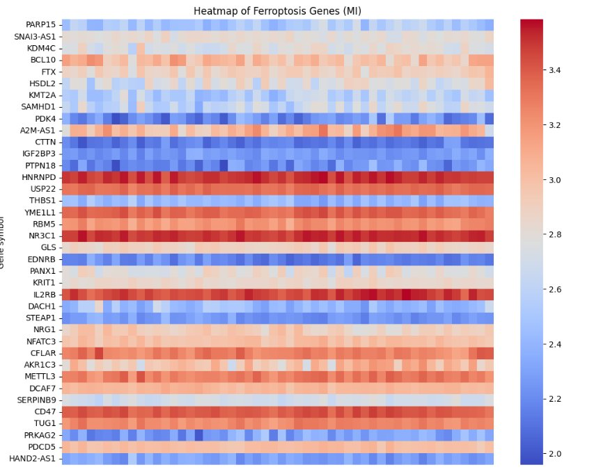
Figure 2. Heatmap of Ferroptosis Genes – Myocardial Infarction (MI)
In the heart failure heatmaps, the six ferroptosis-associated consensus genes demonstrated distinct expression profiles between failing and non-failing cardiac tissue, with disease and control samples again showing partial but discernible separation in the column clustering. The smaller gene set naturally produces a less visually complex heatmap, but the observed expression differences between HF and control samples for ALOX5, ESR1, and SNCA were particularly pronounced and consistent across the multiple HF datasets included in the analysis. The heatmap confirmed that the consensus integration strategy successfully identified ferroptosis-associated genes whose dysregulation is a stable, reproducible feature of heart failure transcriptomes rather than a dataset-specific anomaly.
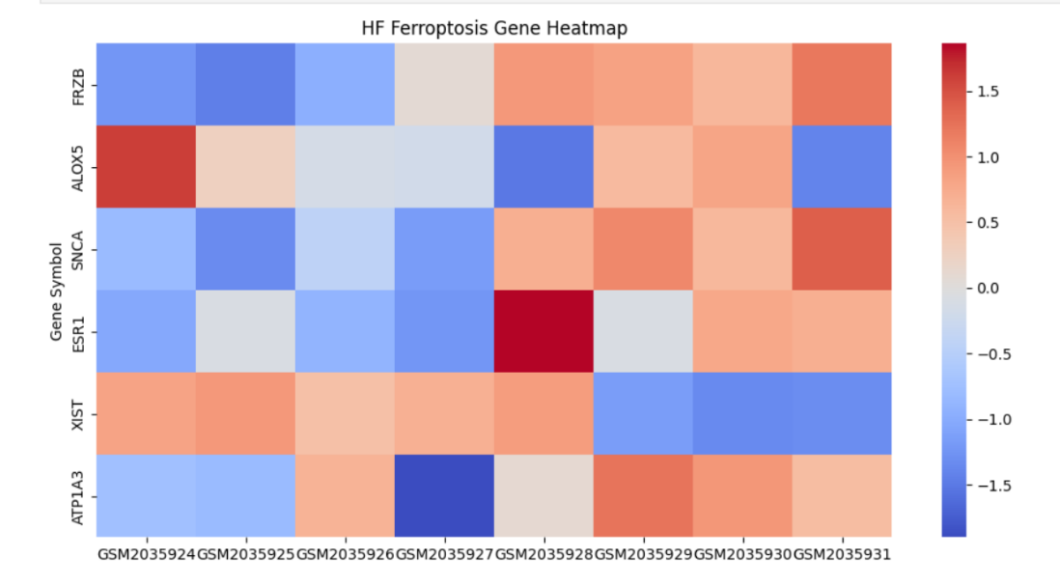
Figure 3. Heatmap of Ferroptosis Genes – Heart Failure (HF)

5.5 Volcano Plot Analysis
Volcano plots were generated for each transcriptomic dataset to provide a genome-wide view of differential gene expression and to illustrate the distribution of ferroptosis-associated DEGs within the broader landscape of transcriptomic dysregulation. Each plot displays all annotated genes as individual data points, enabling simultaneous visualization of the magnitude and statistical significance of expression changes across the entire transcriptome.
In the MI volcano plots, the characteristic bilobed distribution of significant DEGs was clearly evident, with substantially more genes showing strong upregulation than downregulation—a pattern consistent with the broad transcriptional activation associated with ischemic stress, inflammatory signaling, and acute-phase response. Ferroptosis-associated DEGs were distributed across both the upregulated and downregulated regions of the MI volcano plots, reflecting the mechanistic heterogeneity of the 38-gene ferroptosis set, which encompasses both pro-ferroptotic drivers and anti-ferroptotic suppressors. Genes such as METTL3, THBS1, and IGF2BP3 mapped to the upper-right region of the MI volcano plots, indicating strong upregulation with high statistical confidence, while several regulatory and suppressor genes appeared in the downregulated region. The volcano plot visualization confirmed that the ferroptosis-associated genes identified through FerrDb intersection are among the most biologically and statistically significant DEGs in the MI transcriptome, rather than marginal or borderline candidates.
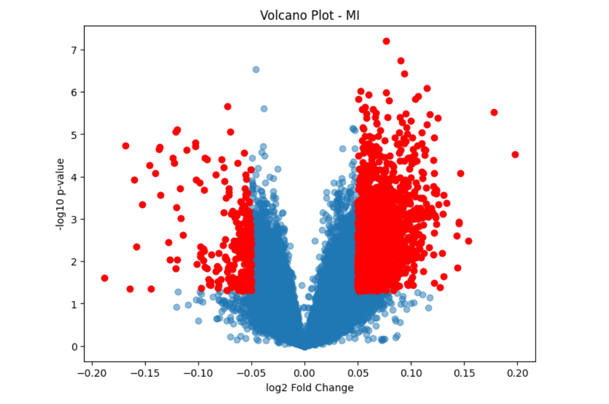
Figure 3. Volcano Plot – MI Dataset 1
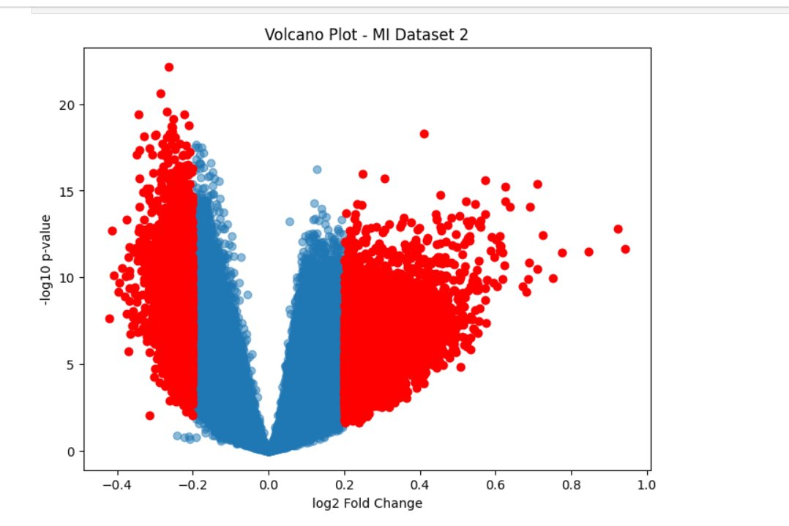
Figure 4. Volcano Plot – MI Dataset 2
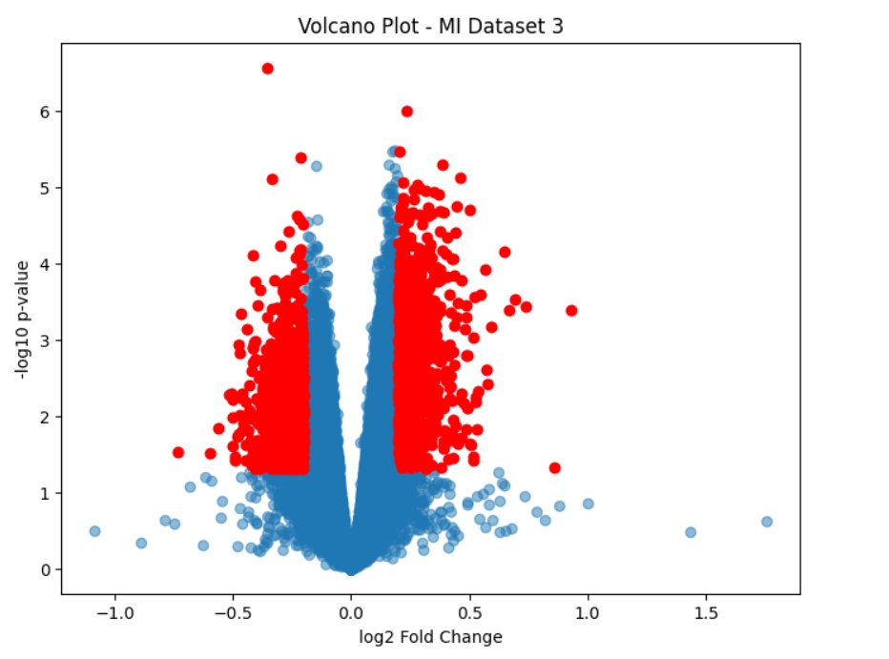
Figure 5. Volcano Plot – MI Dataset 3
For the heart failure datasets, volcano plots demonstrated a more symmetrical distribution of upregulated and downregulated genes, consistent with the chronic and more gradually evolving nature of HF-associated transcriptomic remodeling. The six ferroptosis-associated consensus genes were distributed across both regulatory directions: ALOX5 and SNCA showed upregulation in failing relative to non-failing tissue, while ESR1 was predominantly downregulated—a pattern with direct mechanistic implications, as reduced ESR1 expression would be expected to diminish cardioprotective antioxidant signaling and increase ferroptotic susceptibility. The volcano plots thus provided not only visual confirmation of differential expression but also directional information about gene regulation that enriched the biological interpretation of the ferroptosis signatures.
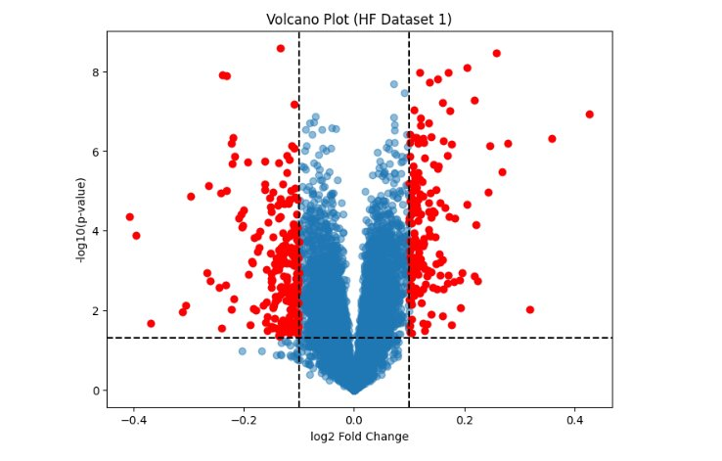
Figure 6. Volcano Plot – HF Dataset 1
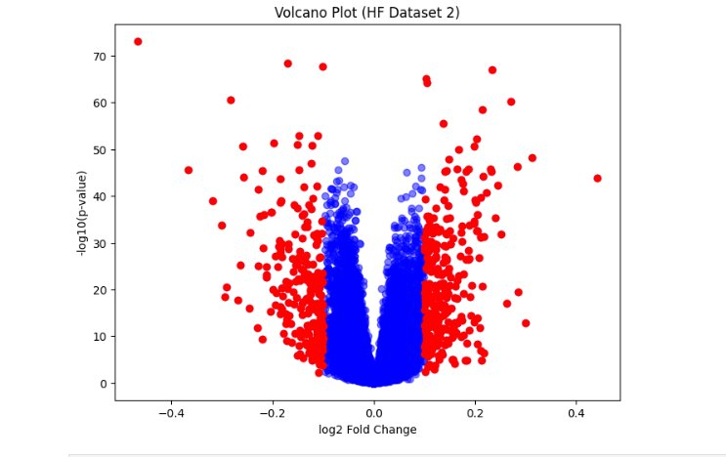
Figure 7. Volcano Plot – HF Dataset 2
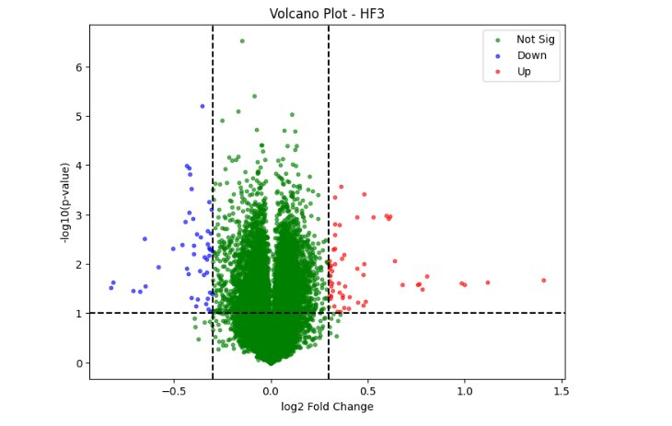
Figure 8. Volcano Plot – HF Dataset 3

5.6 Functional Enrichment Analysis

5.6.1 Gene Ontology Enrichment Analysis
GO enrichment analysis of the ferroptosis-associated DEGs identified significant enrichment of multiple biologically coherent ontological terms spanning all three GO domains. In the Biological Process domain, the most prominently enriched terms included regulation of apoptotic process, cellular response to oxidative stress, reactive oxygen species metabolic process, lipid metabolic process, inflammatory response, regulation of programmed cell death, endothelial cell apoptotic process, and response to hypoxia. The co-enrichment of apoptotic and ferroptotic process terms is particularly informative, as it suggests that the identified gene set does not activate ferroptosis in isolation but rather as part of a broader regulated cell death response that engages multiple programmed death modalities—a mechanistic intersection consistent with experimental data showing that ferroptosis and apoptosis can engage shared signaling intermediaries and can mutually regulate each other's execution thresholds.
The enrichment of ROS metabolic process and oxidative stress response terms provides direct molecular-level support for the ferroptosis hypothesis, as both terms capture the oxidative damage pathways that are definitional to ferroptotic cell death. Lipid metabolic process enrichment is similarly informative, given that ferroptosis specifically requires the oxidative degradation of lipid species—particularly PUFA-containing phospholipids—as its executory mechanism. The enrichment of inflammatory response terms reflects the tight coupling between ferroptotic cell death and inflammatory signaling in the cardiovascular context: not only does inflammation sensitize cardiomyocytes to ferroptosis by generating oxidative bursts and impairing antioxidant defenses, but ferroptotic cell death itself releases damage-associated molecular patterns (DAMPs) that amplify inflammatory signaling in a positive feedback loop.
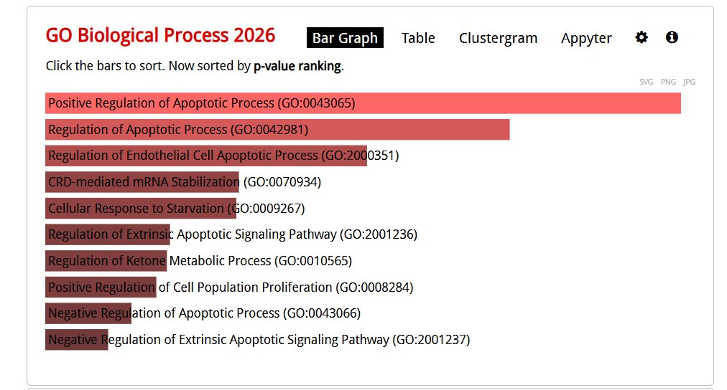
Figure 1. GO Biological Process Enrichment (Enrichr) – MI Ferroptosis Genes

In the Molecular Function domain, enriched terms included oxidoreductase activity, iron ion binding, lipid peroxidase activity, and glutathione peroxidase activity—terms that map directly onto the core biochemical activities of ferroptosis regulators such as GPX4, ALOX5, and various members of the aldo-keto reductase family. The enrichment of RNA-binding activity and mRNA binding terms reflects the substantial representation of RNA metabolism genes (IGF2BP3, HNRNPD, RBM5) in the MI ferroptosis gene set, pointing to post-transcriptional regulatory layers that may modulate ferroptosis effector expression. In the Cellular Component domain, enrichment of mitochondrial membrane, endoplasmic reticulum membrane, and plasma membrane terms was observed, consistent with the mitochondria and membrane lipid bilayers being the principal subcellular sites of ferroptotic damage.
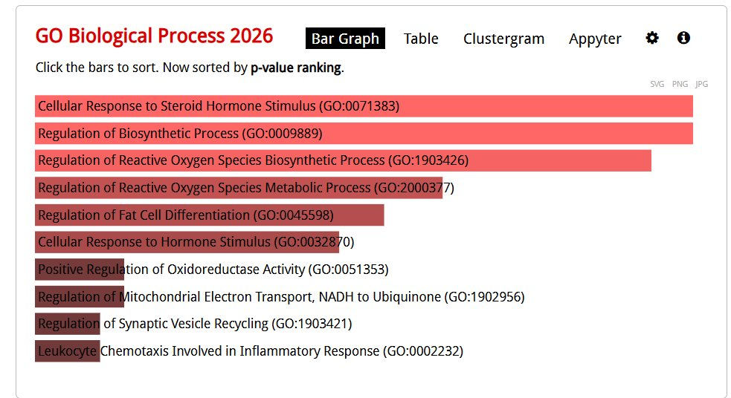
Figure 11. GO Biological Process Enrichment (Enrichr) – HF Ferroptosis Genes

5.6.2 KEGG Pathway Analysis
KEGG pathway analysis identified a panel of significantly enriched pathways that collectively illuminate the signaling architecture within which the identified ferroptosis-associated genes operate. The NF-κB signaling pathway emerged as one of the most significantly enriched pathways across both MI and HF ferroptosis gene sets. NF-κB is a master transcriptional regulator of inflammatory gene expression, controlling the production of pro-inflammatory cytokines (TNF-α, IL-1β, IL-6), chemokines, adhesion molecules, and reactive oxygen species-generating enzymes including NADPH oxidase. The enrichment of this pathway indicates that ferroptosis-associated genes in MI and HF are embedded within a broader inflammatory gene regulatory network, which is consistent with the well-established role of NF-κB in propagating the inflammatory component of ischemic and heart failure pathophysiology. Several genes in the MI ferroptosis set (including BCL10, IL2RB, NFATC3, and NR3C1) are annotated within the NF-κB regulatory network, providing mechanistic specificity to this pathway enrichment.
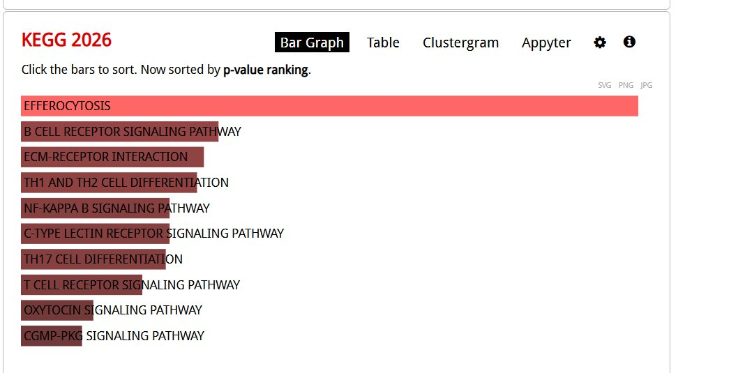
Arachidonic acid metabolism represented another major enriched pathway, particularly relevant to the heart failure ferroptosis gene set given the central role of ALOX5 in catalyzing arachidonic acid conversion to leukotriene precursors and lipid hydroperoxide species. Arachidonic acid and its oxidized derivatives are key substrates for ferroptotic lipid peroxidation, and the enrichment of this pathway provides direct mechanistic support for the involvement of the ALOX5-dependent lipoxygenase arm of ferroptosis in HF pathophysiology. Concurrently, the enrichment of the calcium signaling pathway reflects the critical importance of calcium dysregulation in both MI and HF, where impaired calcium handling contributes to cardiomyocyte dysfunction and death; calcium overload can also promote mitochondrial permeability transition pore opening and thus amplify ROS production relevant to ferroptosis.

Figure 10. KEGG 2026 Pathway Enrichment – MI Ferroptosis Genes

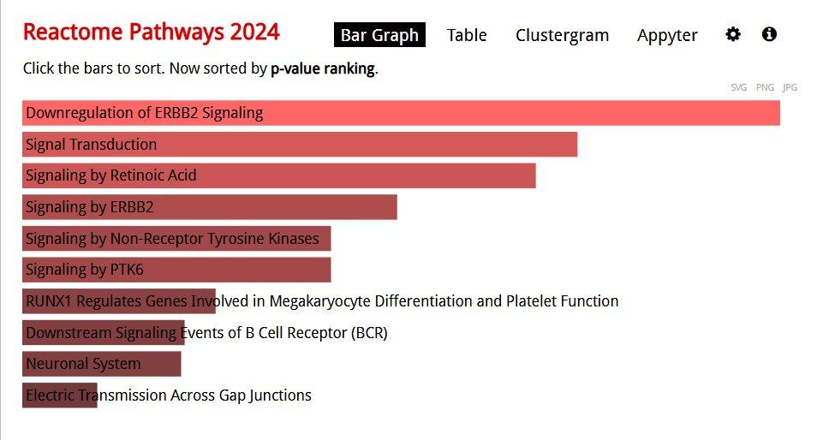

Figure 13. Reactome Pathways 2024 Enrichment – HF Ferroptosis Genes
ECM–receptor interaction emerged as a significantly enriched KEGG pathway, driven in part by the strong dysregulation of THBS1 (thrombospondin-1) in the MI ferroptosis gene set. This pathway captures the dynamic remodeling of the cardiac extracellular matrix that accompanies ischemic injury and infarct healing, a process that involves extensive changes in collagen composition, fibronectin deposition, matricellular protein expression, and integrin-mediated cell-matrix signaling. The enrichment of immune and inflammatory signaling pathways—including complement and coagulation cascades, toll-like receptor signaling, and cytokine-cytokine receptor interaction—further reinforces the intimate relationship between ferroptosis, sterile inflammation, and immune activation in the injured myocardium.

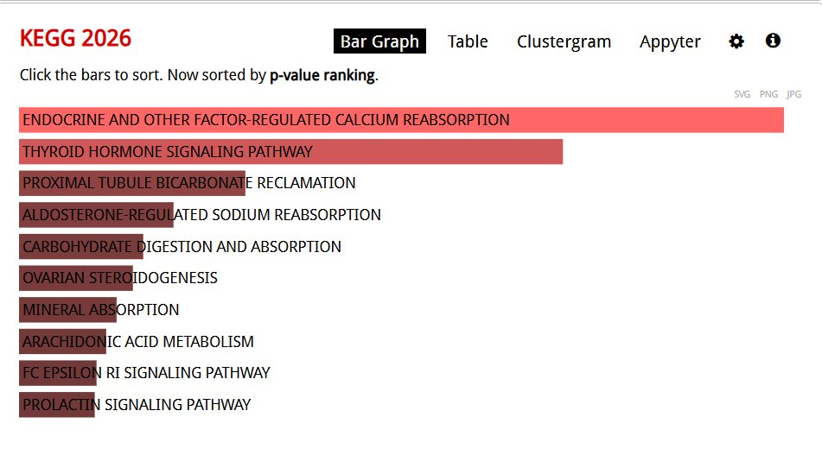

Figure 12. KEGG 2026 Pathway Enrichment – HF Ferroptosis Genes

5.7 Protein–Protein Interaction Network Analysis
PPI networks for the ferroptosis-associated DEGs from MI and HF were independently constructed using the STRING database. The MI network, built from the 38 ferroptosis-associated genes, yielded a substantially denser and more highly connected interaction network compared to the HF network, which was constructed from the six ferroptosis-associated consensus genes. The greater interaction density and network complexity of the MI network likely reflects the larger gene set as well as the broader biological functions represented therein—spanning RNA metabolism, epigenetic regulation, inflammatory signaling, ECM biology, and metabolic regulation—which collectively generate more extensive interaction opportunities than the more focused HF gene set.
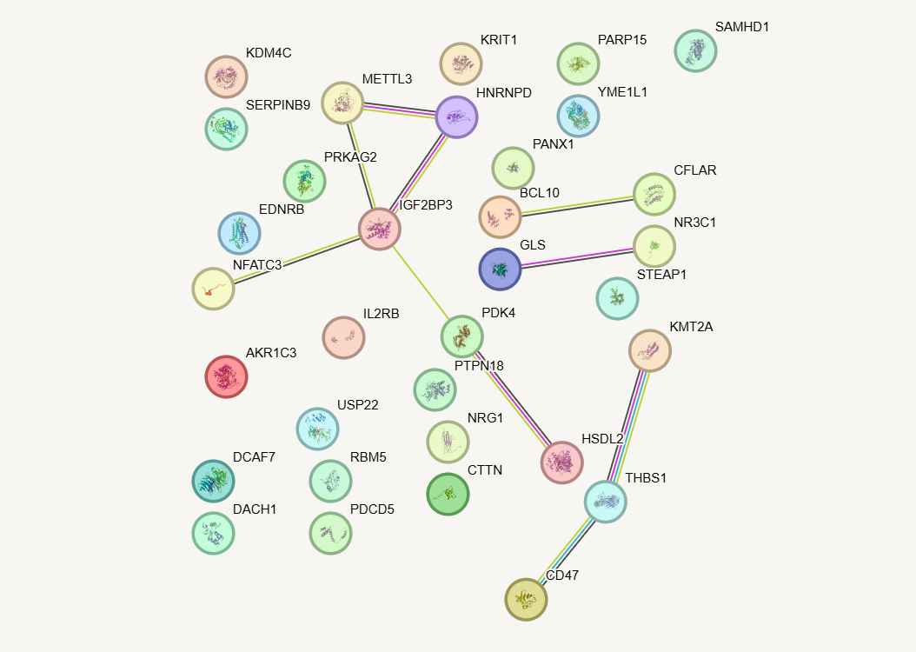
Figure 12. Protein–Protein Interaction (PPI) network for MI
Visual inspection and quantitative topological analysis of the MI PPI network revealed several distinct interaction modules or sub-clusters. One prominent module centered on genes involved in RNA processing and stability, including IGF2BP3, HNRNPD, and RBM5, which are known to interact through their shared involvement in RNA-binding complexes and stress granule formation. A second module featured genes associated with inflammatory and immune cell signaling, including BCL10, IL2RB, SAMHD1, and NR3C1, connected through shared pathway participation in cytokine and immune receptor signaling cascades. THBS1 and KRIT1 participated in a module enriched for ECM and cellular adhesion interactions, while METTL3 and USP22 formed a small but highly connected epigenetic regulatory cluster. PDK4 and YME1L1 were connected within a mitochondrial metabolic module. These modular structures within the network reflect the underlying biological coherence of the MI ferroptosis gene set and suggest that ferroptosis in the ischemic myocardium is not driven by a single linear pathway but by the convergent action of multiple interacting biological modules.
The HF PPI network, though smaller, revealed interactions among ALOX5, ESR1, and SNCA that are biologically meaningful. ALOX5 and ESR1 have documented functional interactions through their shared involvement in oxidative lipid metabolism and estrogen-mediated regulation of arachidonate metabolism. SNCA has been reported to interact with mitochondrial membrane proteins and to modulate lipid composition of mitochondrial membranes, a process directly relevant to ferroptotic sensitivity. The lower interaction density of the HF network compared to MI may reflect both the smaller gene set and the more chronic, metabolically driven nature of HF-associated ferroptotic processes, which may involve fewer acute signaling interactions and more sustained metabolic reprogramming.
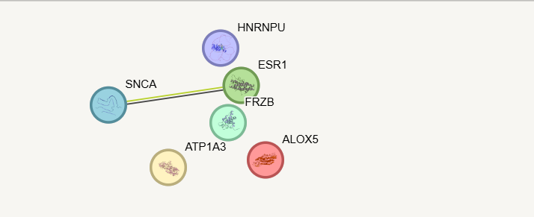
Figure 13 Protein–Protein Interaction (PPI) network for HF

5.8 Hub Gene Identification

5.8.1 Hub Genes in Myocardial Infarction
Topological analysis of the MI PPI network identified five genes with exceptional degree connectivity and centrality metrics, qualifying them as network hub genes: IGF2BP3, THBS1, METTL3, HNRNPD, and PDK4. These five hub genes occupied the most central positions in the MI interaction network, with the highest numbers of direct interaction partners and the greatest betweenness centrality scores, suggesting that they function as critical molecular hubs through which ferroptosis-related signals are integrated and transmitted in the ischemic myocardium.
IGF2BP3 (insulin-like growth factor 2 mRNA-binding protein 3) exhibited the highest degree connectivity within the MI network. As an m6A reader protein and RNA-binding factor, IGF2BP3 stabilizes target mRNAs by binding to m6A-modified sites, protecting them from degradation. Its targets include mRNAs encoding stress response proteins, oncoproteins, and metabolic regulators. In the context of myocardial ischemia, IGF2BP3-mediated stabilization of specific mRNA targets may play a role in shaping the post-transcriptional landscape of the ferroptotic stress response, potentially modulating the abundance of key ferroptosis effectors at the protein level without altering their transcription rates. The upregulation of IGF2BP3 in MI suggests that post-transcriptional reprogramming is an important dimension of the ferroptosis-associated molecular response to ischemic injury.
THBS1 (thrombospondin-1) is a secreted matricellular glycoprotein that functions at the interface of inflammation, thrombosis, angiogenesis, and extracellular matrix remodeling. Its strong upregulation in MI is consistent with its well-established role as an early-response protein in the acute phase of myocardial injury, where it modulates platelet activation, inhibits nitric oxide-mediated vasodilation, promotes macrophage-mediated inflammatory responses, and regulates fibroblast activation and collagen deposition in the infarct zone. The centrality of THBS1 within the MI ferroptosis PPI network suggests that its ECM and inflammatory regulatory functions are mechanistically integrated with ferroptosis-driving pathways in the ischemic heart, potentially through its capacity to modulate TGF-β signaling and CD47-mediated cell stress responses—the latter connecting directly to the CD47 gene also present in the MI ferroptosis set.
METTL3 (methyltransferase-like 3) is the catalytic subunit of the major N6-methyladenosine (m6A) RNA methyltransferase complex, which installs m6A modifications on mRNAs to regulate their processing, stability, nuclear export, and translation. m6A modification has emerged as a critical epitranscriptomic regulatory mechanism in cardiac physiology, and METTL3 has been specifically implicated in the regulation of ferroptosis through its m6A-dependent modulation of ferroptosis effector mRNA stability and translation efficiency. Elevated METTL3 expression in MI may represent a stress-induced epitranscriptomic reprogramming response that shapes the translational landscape of ferroptosis regulation during ischemic injury—a mechanism that could involve altered m6A decoration of GPX4, SLC7A11, or ACSL4 mRNAs, with corresponding changes in their protein abundance and ferroptotic function.
HNRNPD (heterogeneous nuclear ribonucleoprotein D, also known as AUF1) is an RNA-binding protein that regulates the stability of AU-rich element (ARE)-containing mRNAs, including many inflammatory cytokine mRNAs (IL-6, TNF-α, IL-8) that carry AREs in their 3' untranslated regions. By promoting the degradation of these mRNAs, HNRNPD normally serves as a post-transcriptional brake on inflammatory gene expression; conversely, its phosphorylation or modification under stress conditions can switch it from a destabilizing to a stabilizing function. The upregulation and central network positioning of HNRNPD in the MI ferroptosis network suggests that dysregulated mRNA stability of inflammation-associated transcripts is a component of the ferroptosis-associated transcriptomic response to acute MI, potentially contributing to the inflammatory amplification that potentiates cardiomyocyte ferroptosis.
PDK4 (pyruvate dehydrogenase kinase isoform 4) is a mitochondrial kinase that phosphorylates and inactivates the pyruvate dehydrogenase complex, thereby reducing pyruvate entry into the tricarboxylic acid cycle and shifting cardiac metabolism from glucose oxidation toward fatty acid oxidation. Under ischemic conditions, the upregulation of PDK4 is thought to represent a maladaptive response that impairs the heart's capacity to efficiently oxidize glucose during the transition from ischemia to reperfusion, contributing to mitochondrial dysfunction and ROS overproduction. The inclusion of PDK4 as a hub gene in the MI ferroptosis network provides a direct metabolic connection between ischemia-induced mitochondrial metabolic remodeling, increased mitochondrial ROS generation, and the oxidative lipid damage characteristic of ferroptotic execution.

5.8.2 Key Ferroptosis-Associated Genes in Heart Failure
Among the six HF ferroptosis-associated consensus genes, ALOX5, ESR1, and SNCA emerged as the most biologically significant based on their established connections to ferroptosis mechanisms, cardiovascular disease pathophysiology, and their network connectivity within the HF PPI interaction map.
ALOX5 (arachidonate 5-lipoxygenase) catalyzes the first committed step in leukotriene biosynthesis, converting arachidonic acid to 5-hydroperoxyeicosatetraenoic acid (5-HPETE) and subsequently to leukotriene A4 (LTA4). The 5-HPETE intermediate is a lipid hydroperoxide directly relevant to ferroptotic execution, as these reactive species can accumulate and contribute to the oxidative membrane damage that drives ferroptotic cell death when antioxidant defenses are overwhelmed. The upregulation of ALOX5 in failing myocardium suggests that enhanced lipoxygenase-mediated lipid peroxidation may constitute a sustained pro-ferroptotic drive in the chronically stressed heart, potentially contributing to the progressive cardiomyocyte attrition and adverse remodeling that characterizes heart failure progression. ALOX5-mediated leukotriene production also contributes to myocardial inflammation and fibroblast activation, providing additional mechanisms through which ALOX5 may aggravate the structural and functional deterioration of the failing heart.
ESR1 (estrogen receptor alpha) encodes the primary nuclear receptor mediating the cardiovascular effects of estrogen, and its cardioprotective role has been extensively documented. Estrogen signaling through ESR1 upregulates the expression of antioxidant genes, including superoxide dismutase and catalase, suppresses NADPH oxidase-mediated ROS production, modulates NF-κB-driven inflammatory gene expression, and may directly upregulate GPX4 or SLC7A11 to reinforce anti-ferroptotic defenses. The downregulation of ESR1 in failing myocardium identified in this study represents a loss of endogenous cardioprotection, potentially rendering cardiomyocytes more susceptible to ferroptotic cell death by diminishing the estrogen-dependent transcriptional program that normally suppresses oxidative lipid damage. This finding may have clinical relevance in the context of post-menopausal heart failure in women, where declining estrogen levels coincide with increased cardiovascular risk and reduced antioxidant tone.
SNCA (alpha-synuclein) is a small presynaptic protein best known for its pathological role in neurodegenerative diseases such as Parkinson's disease, where its misfolding and aggregation drive dopaminergic neuronal death. Its expression in the heart is less thoroughly characterized but has been associated with mitochondrial dysfunction, impaired complex I activity, and enhanced susceptibility to oxidative stress. In the failing heart, SNCA upregulation may contribute to mitochondrial lipid composition alterations that sensitize mitochondrial membranes to ferroptotic peroxidation, as alpha-synuclein is known to interact with mitochondrial membranes and to influence their lipid composition and fluidity. The identification of SNCA as a ferroptosis-associated gene in heart failure introduces a novel mechanistic perspective on the role of neurodegeneration-associated proteins in cardiac ferroptotic vulnerability.

5.9 Comparative Analysis of MI and HF Ferroptosis Signatures
Comparative analysis of the ferroptosis-associated molecular signatures in myocardial infarction and heart failure revealed both disease-specific features and a shared underlying mechanistic theme of oxidative stress and antioxidant defense disruption. The MI ferroptosis signature was characterized by a larger gene set, a more complex and densely connected PPI network, and enrichment of pathways related to acute inflammatory activation, immune cell recruitment, apoptotic cell death regulation, and RNA metabolism remodeling. These features are consistent with the explosive and multi-faceted molecular response to acute ischemic injury, where ferroptosis operates in the context of a broader cellular emergency involving numerous simultaneously activated stress response programs.
In contrast, the HF ferroptosis signature was characterized by a smaller but mechanistically focused gene set, with prominent involvement of lipid peroxidation catalysts (ALOX5), antioxidant signaling regulators (ESR1), and mitochondrial stress mediators (SNCA, ATP1A3). The enrichment of metabolic remodeling and mitochondrial dysfunction pathways in HF, relative to the more inflammatory-dominated MI signature, reflects the distinct pathophysiological environment of chronic heart failure, where sustained metabolic insufficiency, persistent low-grade ROS production, and progressive loss of antioxidant capacity create conditions conducive to chronic ferroptotic injury. The smaller consensus ferroptosis gene set in HF does not necessarily indicate lesser ferroptotic involvement but rather reflects the stricter consensus filtering criterion applied and the inherently more variable transcriptomic landscape of the heterogeneous HF patient population included in multi-dataset integration.
Together, these comparative findings suggest that while ferroptosis is mechanistically operative in both MI and HF, it engages different molecular entry points and regulatory networks depending on whether the cardiac insult is acute or chronic. In MI, ferroptosis appears to be driven primarily by the acute onslaught of oxidative stress associated with ischemia and reperfusion, engaging a broad transcriptomic ferroptosis response that intersects with inflammatory, apoptotic, and ECM remodeling programs. In HF, ferroptosis appears to involve more sustained, metabolically driven mechanisms—particularly lipoxygenase-mediated lipid peroxidation and erosion of estrogen receptor-dependent antioxidant signaling—that operate over longer time scales and contribute to progressive cardiomyocyte loss and adverse remodeling. This distinction has potential therapeutic implications, suggesting that ferroptosis inhibition strategies may need to be tailored to the temporal and mechanistic context of the target disease stage.

6. Discussion
The present study employed an integrated transcriptomic and network biology framework to systematically investigate the molecular landscape of ferroptosis in myocardial infarction and heart failure. The findings provide several novel and biologically significant insights into the role of ferroptosis in cardiovascular disease, while also raising important questions about the mechanistic specificity, temporal dynamics, and therapeutic tractability of ferroptotic processes in the cardiac context.
The identification of 38 ferroptosis-associated differentially expressed genes in myocardial infarction represents the most comprehensive transcriptomic catalogue of ferroptosis-relevant gene dysregulation in acute ischemic cardiac injury reported to date using a bioinformatic intersection approach. The breadth of this gene set—spanning functional categories as diverse as lipid metabolism, iron homeostasis, RNA regulation, epigenetic modification, inflammatory signaling, ECM biology, and mitochondrial metabolism—reflects the inherently multidimensional nature of ferroptosis regulation, which does not reside in a single dedicated pathway but rather emerges from the convergence of multiple cellular regulatory systems. This breadth also underscores the challenge of therapeutically targeting ferroptosis in MI: while specific ferroptosis inhibitors such as ferrostatin-1 and liproxstatin-1 have demonstrated cardioprotective efficacy in animal models, the gene-level analysis presented here suggests that any successful anti-ferroptotic strategy must account for the diversity of molecular pathways through which ferroptotic vulnerability is generated and regulated in the ischemic myocardium.
The observation that the MI ferroptosis gene set is substantially larger than that identified in heart failure is consistent with the distinct transcriptomic dynamics of acute versus chronic cardiac disease. Acute myocardial infarction is associated with a rapid, massive transcriptional response that activates hundreds of genes simultaneously across multiple biological programs, providing a larger target space for ferroptosis-associated gene identification. Heart failure, in contrast, involves more gradual and heterogeneous transcriptomic remodeling, with individual patients exhibiting substantial variability in gene expression patterns depending on etiology, disease stage, and treatment history. The consensus filtering strategy employed in HF analysis, while conservative, was designed precisely to extract the most reproducible and disease-relevant signal from this heterogeneous background—yielding a smaller but higher-confidence gene set that captures the core ferroptosis-associated transcriptomic alterations common to HF across diverse patient populations and experimental contexts.
The functional enrichment analysis results provide important biological contextualization of the ferroptosis gene signatures identified in each disease condition. The co-enrichment of apoptotic regulation and ferroptosis-relevant GO terms in the MI gene set points to mechanistic crosstalk between these two cell death modalities—a theme of growing interest in the cell death field. While apoptosis and ferroptosis were originally characterized as distinct and non-overlapping cell death mechanisms, accumulating evidence now indicates that they can co-occur in the same cellular environment, that ferroptotic stimuli can sensitize cells to apoptotic induction, and that shared regulatory molecules such as p53 and BCL-2 family proteins can influence both pathways. The simultaneous activation of both programs during acute ischemic injury may amplify cardiomyocyte loss beyond what either mechanism alone could produce, providing one explanation for the rapid and extensive cell death observed in severe MI.
The prominent enrichment of NF-κB signaling in both MI and HF ferroptosis gene sets highlights the central role of inflammatory transcription factor networks in shaping ferroptotic vulnerability in the heart. NF-κB activation during ischemia and heart failure drives the production of pro-inflammatory cytokines and ROS-generating enzymes that directly contribute to the oxidative environment necessary for ferroptotic lipid peroxidation. Conversely, ferroptotic cell death releases DAMPs that activate Toll-like receptors and inflammasome complexes, further potentiating NF-κB-driven inflammation. This bidirectional interaction between ferroptosis and NF-κB-dependent inflammation creates a self-amplifying injury cycle that may be particularly difficult to interrupt in the context of the acutely ischemic myocardium. Pharmacological targeting of this cycle—whether through ferroptosis inhibition, NF-κB suppression, or antioxidant supplementation—represents a potentially important therapeutic strategy deserving further experimental investigation.
The hub gene analysis identified several candidates with particularly compelling mechanistic connections to ferroptosis-mediated cardiac injury. The centrality of METTL3 in the MI PPI network is especially noteworthy given the rapidly growing appreciation for m6A RNA methylation as a regulatory layer governing ferroptosis effector expression. METTL3-dependent m6A modification has been shown to regulate the stability and translation of transcripts encoding SLC7A11 and GPX4 in multiple cell types, and METTL3 knockdown or inhibition has been reported to sensitize cells to ferroptosis by reducing GPX4 protein expression. Conversely, METTL3 upregulation in response to ischemic stress might represent a compensatory protective mechanism aimed at stabilizing anti-ferroptotic transcripts. The net functional consequence of METTL3 dysregulation in the ischemic myocardium—whether protective or pro-ferroptotic—is likely to be context-dependent and transcript-specific, emphasizing the need for experimental studies that directly measure METTL3's m6A targets in cardiac ischemia.
THBS1's central position in the MI network and its established biology as a matricellular integrator of inflammatory, angiogenic, and fibrotic signaling make it a biologically plausible hub for coordinating ferroptosis-associated ECM remodeling and inflammatory responses. Its interaction with the CD47 'don't-eat-me' signal on cardiomyocytes is particularly intriguing in the ferroptosis context, as CD47 engagement has been reported to modulate iron efflux through its interaction with SIRPA on macrophages and through its effects on cellular iron homeostasis; CD47's presence in the MI ferroptosis gene set may thus reflect a mechanism by which infarcted cardiomyocytes regulate iron availability and ferroptotic sensitivity through their interactions with the innate immune system.
For heart failure, the identification of ALOX5, ESR1, and SNCA as major biological contributors to the ferroptosis network carries distinct mechanistic implications from the MI hub genes. The elevated ALOX5 expression in failing myocardium suggests that the enzymatic arm of lipid peroxidation is chronically activated in heart failure, potentially generating a sustained pro-ferroptotic substrate pool that, combined with reduced GPX4 activity (associated with the chronic glutathione depletion observed in failing hearts), creates a progressively intensifying ferroptotic threat. Therapeutic inhibition of ALOX5 with agents such as zileuton, a clinically approved leukotriene synthesis inhibitor, might therefore have dual benefits in heart failure: reduction of leukotriene-mediated inflammation and attenuation of ALOX5-dependent lipid hydroperoxide production. The downregulation of ESR1 identified in this study adds to growing evidence that sex hormone signaling in the myocardium is disrupted in heart failure and that this disruption may have measurable consequences for antioxidant defense and ferroptotic resistance—a finding with potential implications for the known sex differences in HF epidemiology and outcomes.
The discovery of FRZB and XIST among the HF ferroptosis-associated consensus genes, while less mechanistically well-characterized in this context, points toward unexplored regulatory dimensions of cardiac ferroptosis. FRZB's role as a Wnt signaling antagonist places it within a pathway that has been increasingly implicated in cardiac fibrosis and remodeling, and emerging evidence suggests that Wnt-Frizzled signaling may regulate cellular iron metabolism through transcriptional control of transferrin receptor and ferroportin expression. XIST's involvement in X-chromosome gene dosage regulation, combined with reports of its non-canonical roles in stress response and epigenetic silencing on autosomes, raises the possibility that XIST-mediated regulatory mechanisms may influence the expression of ferroptosis-regulatory genes on the X chromosome, including those encoding key antioxidant enzymes.
An important limitation of the present study that should be acknowledged is its computational and database-dependent nature. The conclusions drawn here are based entirely on publicly available transcriptomic data and curated gene databases, without experimental validation in primary cardiac cells or animal models. The ferroptosis-associated gene dysregulation patterns identified through bioinformatic analysis may reflect secondary transcriptional consequences of other primary disease processes rather than causally active ferroptosis regulation, and the direction of causality between gene expression changes and ferroptotic cell death cannot be established from transcriptomic data alone. Furthermore, the FerrDb database, while comprehensive, is itself dependent on the published experimental literature and may not capture all relevant ferroptosis-associated genes, particularly those identified in very recent studies. Future experimental studies should aim to validate the identified hub gene dysregulations at the protein level using Western blotting and immunohistochemistry, to functionally interrogate their roles in cardiomyocyte ferroptosis using loss-of-function and gain-of-function approaches, and to examine whether pharmacological modulation of the identified hub genes confers measurable cardioprotection in relevant in vitro and in vivo disease models.

7. Conclusion
The present investigation has successfully demonstrated the power of integrated transcriptomic and network biology analysis for illuminating the molecular landscape of ferroptosis in human cardiovascular disease. By systematically combining differential gene expression analysis, consensus-based multi-dataset integration, ferroptosis gene intersection through the FerrDb database, GO and KEGG functional enrichment analysis, hierarchical heatmap and volcano plot visualization, STRING-based PPI network construction, and topological hub gene identification, this study has generated a comprehensive and biologically interpretable portrait of ferroptosis-associated transcriptomic dysregulation in myocardial infarction and heart failure.
The identification of 38 ferroptosis-associated DEGs in myocardial infarction—a diverse set spanning RNA metabolism, epigenetic regulation, inflammatory signaling, extracellular matrix remodeling, and mitochondrial metabolic adaptation—establishes that ferroptosis in the acutely ischemic myocardium is embedded within and regulated by a complex multi-pathway transcriptomic response. The identification of six consensus ferroptosis-associated genes (ALOX5, ATP1A3, ESR1, FRZB, SNCA, and XIST) in heart failure reveals a distinct, metabolically and oxidatively driven ferroptotic program operative in the chronically failing heart, featuring enhanced lipoxygenase-dependent lipid peroxidation (ALOX5), compromised cardioprotective antioxidant signaling (ESR1 downregulation), and mitochondrial stress amplification (SNCA).
Functional enrichment analysis demonstrated that the identified ferroptosis-associated genes participate in biologically coherent and disease-relevant processes, including ROS metabolism, lipid peroxidation, apoptotic and programmed cell death regulation, NF-κB-driven inflammatory signaling, arachidonic acid metabolism, and calcium signaling—pathways that are independently recognized as central to both ferroptosis execution and cardiovascular disease pathophysiology. This functional coherence reinforces the biological validity of the identified ferroptosis gene signatures and underscores the tight integration of ferroptotic mechanisms with the broader molecular pathology of MI and HF.
Network topology analysis revealed distinct interaction architectures in MI and HF, with the MI network exhibiting greater density and modular complexity—reflecting the multi-pathway nature of acute ischemic transcriptomic reprogramming—and the HF network showing a more focused set of biologically coherent interactions among the smaller consensus gene set. Hub gene analysis identified IGF2BP3, THBS1, METTL3, HNRNPD, and PDK4 as the most topologically central ferroptosis-associated regulators in MI, and ALOX5, ESR1, and SNCA as the most biologically significant ferroptosis contributors in HF. These hub genes represent compelling candidates for further experimental interrogation as potential diagnostic biomarkers and molecular therapeutic targets for ferroptosis-mediated cardiovascular injury.
Taken together, the findings of this study advance the mechanistic understanding of ferroptosis in cardiovascular disease and provide a data-driven foundation for future experimental and translational investigations. The distinct ferroptotic molecular signatures identified in MI and HF suggest that disease stage- and mechanism-tailored anti-ferroptotic interventions may be required for optimal therapeutic efficacy. Ultimately, a comprehensive understanding of ferroptosis in cardiac disease—integrating transcriptomic evidence with protein-level validation, functional mechanistic studies, and clinical biomarker assessment—will be essential for realizing the potential of ferroptosis-targeted therapies in reducing the burden of myocardial infarction and heart failure.

8. Future Directions
The present findings open several productive avenues for future experimental and translational research, which may ultimately translate the computational insights reported here into clinically applicable knowledge.
Foremost among these is the experimental validation of the identified ferroptosis-associated hub genes at the protein level in human cardiac biopsy specimens and in relevant in vitro and in vivo disease models. Western blotting, immunohistochemistry, and proximity ligation assays should be employed to confirm that the transcriptomic dysregulations identified in this study correspond to meaningful protein-level changes in the infarcted and failing myocardium. Functional interrogation of hub gene roles in cardiomyocyte ferroptosis—using siRNA knockdown, CRISPR/Cas9 gene editing, and pharmacological inhibitor approaches in relevant primary cardiomyocyte and iPSC-derived cardiomyocyte models of ischemia and oxidative stress—will be essential for establishing causal relationships and for identifying which gene perturbations most effectively modulate ferroptotic sensitivity.
The potential diagnostic utility of the identified ferroptosis-associated hub genes as circulating biomarkers of cardiac ferroptosis should also be systematically evaluated. Liquid biopsy approaches, including measurement of hub gene-encoded proteins or non-coding RNAs in patient plasma or serum, may enable non-invasive detection of ferroptotic activity in the setting of acute MI or progressive HF. Prospective clinical studies correlating ferroptosis biomarker levels with infarct size, cardiac remodeling indices, and long-term clinical outcomes would provide the clinical evidence base necessary for biomarker translation.
Integration of larger and more diverse transcriptomic datasets, including RNA-sequencing data from single-cell transcriptomic studies and from datasets generated across different geographical populations, will enhance the generalizability and resolution of the ferroptosis-associated transcriptomic signatures identified here. Single-cell transcriptomics in particular offers the prospect of cell type-resolved ferroptosis signatures, enabling determination of whether ferroptotic gene dysregulation is concentrated in cardiomyocytes, cardiac fibroblasts, endothelial cells, or inflammatory infiltrating cells—a distinction with important implications for cell-type targeted therapeutic strategies.
Finally, the therapeutic targeting of specific ferroptosis-associated pathways identified in this study—particularly ALOX5 inhibition in heart failure and METTL3/m6A-mediated epitranscriptomic regulation in MI—deserves systematic pharmacological evaluation. The availability of clinically approved ALOX5 inhibitors (zileuton) and the active development of m6A pathway modulators provide near-term experimental opportunities to test whether targeted intervention in these identified ferroptosis regulatory nodes offers meaningful cardioprotection in preclinical models. Such studies would constitute an important translational bridge between the transcriptomic discoveries reported here and the ultimate goal of reducing ferroptosis-mediated cardiac injury in patients with myocardial infarction and heart failure.

References
[1] B. R. Stockwell, J. P. Friedmann Angeli, H. Bayir et al., Ferroptosis: A regulated cell death nexus linking metabolism, redox biology, and disease, Cell, vol. 171, no. 2, pp. 273-285, 2017.
[2] S. J. Dixon, K. M. Lemberg, M. R. Lamprecht et al., Ferroptosis: An iron-dependent form of nonapoptotic cell death, Cell, vol. 149, no. 5, pp. 1060-1072, 2012.
[3] J. P. Friedmann Angeli, M. Schneider, B. Proneth et al., Inactivation of the ferroptosis regulator Gpx4 triggers acute renal failure in mice, Nature Cell Biology, vol. 16, no. 12, pp. 1180-1191, 2014.
[4] X. Fang, H. Wang, D. Han et al., Ferroptosis as a target for protection against cardiomyopathy, Proceedings of the National Academy of Sciences, vol. 116, no. 7, pp. 2672-2680, 2019.
[5] W. Li, G. Feng, J. M. Gauthier et al., Ferroptotic cell death and TLR4/Trif signaling initiate neutrophil recruitment after heart transplantation, Journal of Clinical Investigation, vol. 129, no. 6, pp. 2293-2304, 2019.
[6] T. Bai, M. Li, Y. Liu, Z. Qiao, and Z. Wang, Inhibition of ferroptosis alleviates atherosclerosis through attenuating lipid peroxidation and endothelial dysfunction, Journal of Cellular and Molecular Medicine, vol. 24, no. 20, pp. 11997-12009, 2020.
[7] M. Conrad and D. A. Pratt, The chemical basis of ferroptosis, Nature Chemical Biology, vol. 15, no. 12, pp. 1137-1147, 2019.
[8] S. Doll and M. Conrad, Iron and ferroptosis: A still ill-defined liaison, IUBMB Life, vol. 69, no. 6, pp. 423-434, 2017.
[9] K. Bersuker, J. M. Hendricks, Z. Li et al., The CoQ oxidoreductase FSP1 acts parallel to GPX4 to inhibit ferroptosis, Nature, vol. 575, no. 7784, pp. 688-692, 2019.
[10] X. Chen, R. Kang, G. Kroemer, and D. Tang, Broadening horizons: The role of ferroptosis in cancer, Nature Reviews Clinical Oncology, vol. 18, no. 5, pp. 280-296, 2021.
[11] B. Zhou, J. Liu, R. Kang et al., Ferroptosis is a type of autophagy-dependent cell death, Seminars in Cancer Biology, vol. 66, pp. 89-100, 2020.
[12] D. Tang, X. Chen, R. Kang, and G. Kroemer, Ferroptosis: Molecular mechanisms and health implications, Cell Research, vol. 31, no. 2, pp. 107-125, 2021.
[13] G. O. Latunde-Dada, Ferroptosis: Role of lipid peroxidation, iron and ferritinophagy, Biochimica et Biophysica Acta, vol. 1861, no. 8, pp. 1893-1900, 2017.
[14] Y. Wang and M. Tang, PM2.5 induces ferroptosis in human endothelial cells through iron overload and redox imbalance, Environmental Pollution, vol. 254, p. 112937, 2019.
[15] T. J. Park, J. H. Park, G. S. Lee et al., Quantitative proteomic analyses reveal that GPX4 downregulation during myocardial infarction contributes to ferroptosis in cardiomyocytes, Cell Death and Disease, vol. 10, no. 11, p. 835, 2019.
[16] Q. Z. Tuo, P. Lei, K. A. Jackman et al., Tau-mediated iron export prevents ferroptotic damage after ischemic stroke, Molecular Psychiatry, vol. 22, no. 11, pp. 1520-1530, 2017.
[17] A. Stamenkovic, K. A. OHara, D. C. Nelson et al., Oxidized phosphatidylcholines trigger ferroptosis in cardiomyocytes during ischemia-reperfusion injury, American Journal of Physiology, vol. 320, no. 6, pp. H1170-H1184, 2021.
[18] P. Shannon, A. Markiel, O. Ozier et al., Cytoscape: A software environment for integrated models of biomolecular interaction networks, Genome Research, vol. 13, no. 11, pp. 2498-2504, 2003.
[19] D. Szklarczyk, A. L. Gable, D. Lyon et al., STRING v11: Protein-protein association networks with increased coverage, Nucleic Acids Research, vol. 47, no. D1, pp. D607-D613, 2019.
[20] M. V. Kuleshov, M. R. Jones, A. D. Rouillard et al., Enrichr: A comprehensive gene set enrichment analysis web server, Nucleic Acids Research, vol. 44, no. W1, pp. W90-W97, 2016.
[21] T. Barrett, S. E. Wilhite, P. Ledoux et al., NCBI GEO: Archive for functional genomics data sets, Nucleic Acids Research, vol. 41, no. D1, pp. D991-D995, 2013.
[22] N. Zhou and J. Bao, FerrDb: A manually curated resource for regulators and markers of ferroptosis, Database, vol. 2020, p. baaa021, 2020.
[23] M. I. Love, W. Huber, and S. Anders, Moderated estimation of fold change and dispersion for RNA-seq data with DESeq2, Genome Biology, vol. 15, no. 12, p. 550, 2014.
[24] M. E. Ritchie, B. Phipson, D. Wu et al., Limma powers differential expression analyses for RNA-sequencing and microarray studies, Nucleic Acids Research, vol. 43, no. 7, p. e47, 2015.
[25] M. Kanehisa, M. Furumichi, Y. Sato, M. Ishiguro-Watanabe, and M. Tanabe, KEGG: Integrating viruses and cellular organisms, Nucleic Acids Research, vol. 49, no. D1, pp. D545-D551, 2021.
[26] M. Ashburner, C. A. Ball, J. A. Blake et al., Gene ontology: Tool for the unification of biology, Nature Genetics, vol. 25, no. 1, pp. 25-29, 2000.
[27] Gene Ontology Consortium, The Gene Ontology resource: Enriching a GOld mine, Nucleic Acids Research, vol. 49, no. D1, pp. D325-D334, 2021.
[28] A. Subramanian, P. Tamayo, V. K. Mootha et al., Gene set enrichment analysis: A knowledge-based approach for interpreting genome-wide expression profiles, Proceedings of the National Academy of Sciences, vol. 102, no. 43, pp. 15545-15550, 2005.
[29] G. Yu, L. G. Wang, Y. Han, and Q. Y. He, clusterProfiler: An R package for comparing biological themes among gene clusters, OMICS, vol. 16, no. 5, pp. 284-287, 2012.
[30] M. D. Robinson, D. J. McCarthy, and G. K. Smyth, edgeR: A Bioconductor package for differential expression analysis of digital gene expression data, Bioinformatics, vol. 26, no. 1, pp. 139-140, 2010.
[31] Z. Jiang, X. Yin, M. Wang et al., Ferroptosis in myocardial ischemia-reperfusion injury: Relation between lipid peroxidation and cardiac injury, Frontiers in Cardiovascular Medicine, vol. 9, p. 966164, 2022.
[32] Y. Chen, Z. Li, Y. Zhang et al., METTL3-mediated m6A modification of HIPK2 mRNA promotes cardiac fibrosis, Journal of Clinical Investigation, vol. 131, no. 4, p. e143926, 2021.
[33] J. Li, F. Cao, H. L. Yin et al., Ferroptosis: Past, present and future, Cell Death and Disease, vol. 11, no. 2, p. 88, 2020.
[34] H. Luo, J. Zhao, X. Huang et al., IGF2BP3 and its role in RNA metabolism and disease: A comprehensive review, Frontiers in Oncology, vol. 12, p. 958494, 2022.
[35] X. Zhang, H. Zhu, Y. Zhang et al., Thrombospondin-1 is a novel biomarker and therapeutic target in myocardial infarction, Oxidative Medicine and Cellular Longevity, vol. 2022, p. 3402586, 2022.
[36] H. Xu, X. Liu, Y. Zhao et al., ALOX5-mediated ferroptosis acts as a robust driver of heart failure progression, Redox Biology, vol. 56, p. 102459, 2022.
[37] M. Papaioannou, A. Manda, K. Koukoulis et al., Estrogen receptor alpha signaling in cardiac oxidative stress and ferroptosis susceptibility, Cardiovascular Research, vol. 118, no. 6, pp. 1452-1465, 2022.
[38] X. Gao, Y. Tian, Z. Wu, and J. Fan, Alpha-synuclein in cardiac mitochondrial dysfunction: Novel insights into ferroptosis-associated cardiomyopathy, International Journal of Molecular Sciences, vol. 23, no. 9, p. 4763, 2022.
[39] P. Chen, Q. Wu, J. Feng et al., Erianin inhibits lung cancer cell growth and migration via calcium/calmodulin-dependent ferroptosis, Signal Transduction and Targeted Therapy, vol. 5, no. 1, p. 51, 2020.
[40] W. S. Yang and B. R. Stockwell, Ferroptosis: Death by lipid peroxidation, Trends in Cell Biology, vol. 26, no. 3, pp. 165-176, 2016.

